BUSINESS DEVELOPMENT
FUNDING OPPORTUNITIES FROM USG

TRAINING MANUAL

USAID/Accelerating Support to Advanced Local Partners II Mechanism Contract No.: 7200AA22C00041

ACKNOWLEDGEMENTS
This training manual was developed by:
USAID/Accelerating Support for Advanced Local Partners II (ASAP II)
Catherine Brokenshire-Scott, Project Director
Dr. Valentin Noba, Capacity Advisor for Business Development, ASAP II
Rebecca Boler, Business Development Consultant Kimberly Kane, Senior Capacity Strengthening Advisor Corinna Fales, Editor/Communications Consultant Bashir Ghafarzai, Editor/Communications Consultant

Additional resources available at
www.intrahealth.org/ASAP-Resources
On-demand Webinars on Business Development available in English, French & Portuguese

©2024. All rights reserved by IntraHealth International and USAID.
The contents of this publication are the sole responsibility of IntraHealth International and do not necessarily reflect the views of USAID or the United States Government.

This publication is made possible by the support of the American people through the United States Agency for International Development (USAID) and the President’s Emergency Plan for AIDS Relief (PEPFAR).

ASAP II Business Development Training Manual

TABLE OF CONTENTS

ACRONYMS 3
PROJECT BACKGROUND 4
OVERVIEW OF THE MANUAL 4
Purpose 4
Intended Audience 4
Structure and Content 5
MODULE 1: TRAINING OPENING/INTRODUCTION 6
M 1.1: Pre-Event Preparation 6
M 1.2: Welcome/Opening Remarks 6
M 1.3: Participant and Facilitator Introductions and Expectations 7
M 1.4: Training Agenda, Norms, and Housekeeping Information 8
M 1.5: Training Objectives 9
M 1.6: Training Curriculum Organization 10
M 1.7: Delivery Approach (Facilitator’s/Trainer’s Notes) 11
M 1.8: Participant Assessment 12
MODULE 2: OVERVIEW OF BUSINESS DEVELOPMENT 13
M 2.1: Business Development/Proposal Development in the Context of USG Funding for LIPs 13
M 2.2: Overview of Mechanism and Process for Issuing USG Funding 15
MODULE 3: PRE-SOLICITATION PREPARATION 17
M 3.1: Opportunity Identification 17
M 3.2: Deciding Whether to Pursue the Opportunity 19
M 3.3: Pre-Positioning/Capture Work 20
M 3.4: Forming a Winning Consortium 22
MODULE 4: LIVE PROPOSAL KICK-OFF 25
M 4.1: Getting Organized 25
M 4.2: Understanding Donor and Requirements of Solicitation 29
M 4.3: Proposal Kick-off Meeting 33
M 4.4: Preliminary Steps before Writing the Proposal 33
MODULE 5: RROJECT DESIGN AND PROPOSAL AND BUDGET DEVELOPMENT 36
M 5.1: Project Design and Proposal Development 36
M 5.2: Tips and Considerations for Strong and Compliant Proposal Package 48
M 5.3: Proposal Review and Editing 49
M 5.4: Proposal Finalization and Submission 51
MODULE 6: POST-SUBMISSION PHASE 54
M 6.1: Post-Submission Actions 54
M 6.2: Wrap-up 56
ANNEX A: PRE/POST-TRAINING QUESTIONNAIRES 58
1. Pre-Training Questionnaire 58
2. Post-Training Questionnaire 59
ANNEX B: TOOLS AND TEMPLATES FOR THE PROPOSAL PROCESS 63
Capability Statement 63
Proposal Calendar (Sample) 63
Proposal Review Flow Chart or Guidelines 63
ANNEX C: PRESENTATION SLIDES DECK 64
See separate PowerPoint presentation slides 64
ANNEX D: USEFUL LINKS TO RESOURCES 65
ANNEX E: DETAILED ANNUAL BUDGET 66

ACRONYMS
ASAP Accelerating Support for Advanced Local Partners BD Business Development
EOI Expression of Interest
EMMP Environmental Mitigation and Management Pan
FPD Foundation for Professional Development
G2G Government to Government
GESI Gender Equity and Social Inclusion
LIP Local Implementing Partner
LLD Locally Led Development
MEL Monitoring, Evaluation, and Learning NOFO Notice of Funding Opportunity
PEPFAR U.S. President’s Emergency Plan for AIDS Relief
PPR Past Performance Report
PTA Pre-Teaming Agreement
Q&A Question and Answer
RFA Request for Applications
RFI Request for Information
RFP Request for Proposals
RTC Right to Care
SOW Scope of Work
TAs Teaming Agreements
TA Technical Assistance
ToC Theory of Change
UEI Unique Entity Identifier
USAID United States Agency for International Development USG United States Government

PROJECT BACKGROUND
Accelerating Support to Advanced Local Partners II (ASAP II) is a contract (7200AA22C00041) funded by the United States Agency for International Development (USAID) (May 31, 2022 – July 30, 2024) with the overall goal: “to ensure that local partners have the capabilities and resources to act as prime partners for USAID/PEPFAR programming.” ASAP II has two objectives:
- Strengthen local partners as they transition to receive PEPFAR funding as a USAID prime partner to comply with regulations.
- Prepare local partners to directly manage, implement, and monitor PEPFAR programs, and maintain consistent PEPFAR program achievement and quality.
The ASAP II consortium is led by IntraHealth International as a prime partner, with major subcontractors, including Deloitte Consulting LLP (Deloitte) for government-to-government (G2G) support, Right to Care (RTC) for Strategic Information support, SustainAbility Solutions for pre-award surveys and training in USG rules and regulations, and Foundation for Professional Development (FPD) for accredited training and peer-to-peer learning opportunities.

OVERVIEW OF THE MANUAL

Purpose
The purpose of the Business Development (BD) training manual is to help local organizations on the path to becoming a USAID Prime Partner and the road to future sustainability. The information will help strengthen the capacity of local partners to develop technical and budget proposals to successfully bid for USAID solicitations, for example, Requests for Applications (RFA) or Requests for Proposals (RFP). Local partners will acquire the capabilities and resources to serve as prime recipients of USAID-funded awards, in compliance with donor requirements and procedures.

Intended Audience
The intended audience includes local organizations positioning themselves for USG direct funding and current Local Implementing Partners (LIPs) seeking to strengthen their knowledge and skills in business development (BD) for USG programming. The training is most relevant to staff serving in the positions below:
- Board Members
- Executive Directors
- Program/Project Directors
- Technical
- Finance
- Monitoring and Evaluation

Structure and Content
The training covers the different phases and best practices of the business development process as displayed in the table below. The manual includes a pre-and post-test and numerous useful tools and templates in the annex.
# | TITLE | MODULES
1 | Opening/Introduction | - Pre-Event Preparation
 |  | - Welcome/ Opening Remarks
 |  | - Participant and Facilitator Introductions and Expectations
 |  | - Training Agenda, Norms, and Housekeeping Information
 |  | - Training Objectives
 |  | - Training Curriculum Organization
 |  | - Delivery Approach (Facilitator’s/Trainer’s Notes)
 |  | - Participant Assessment
2 | Overview of Business Development | - Business Development/Proposal Development in the Context of USG Funding for LIPs
 |  | - Overview of Mechanism and Process for Issuing USG Funding
3 | Pre-Solicitation Preparation | - Opportunity Identification
 |  | - Deciding Whether to Pursue the Opportunity
 |  | - Pre-Positioning/Capture Work
 |  | - Overview of Mechanism and Process for Issuing USG Funding
 |  | - Forming a Winning Consortium
4 | Live Proposal Kick-Off | - Getting Organized
 |  | - Understanding Donor and Requirements of Solicitation
 |  | - Proposal Kick-off Meeting
 |  | - Preliminary Steps before Writing the Proposal
5 | Project Design and Proposal and Budget Development | - Project Design and Proposal Development
 |  | - Technical Proposal
 |  | - Cost Proposal
 |  | - Tips and Considerations for a Strong and Compliant Proposal Package
 |  | - Proposal Review and Editing
 |  | - Proposal Finalization and Submission
6 | Post-Submission Phase | - Post-Submission Actions
 |  | - Wrap-up
The content of this training is based on ASAP’s experience working with LIPs in Africa. IntraHealth and its consortium partners on ASAP I and II hope that this training will help in harmonizing efforts to support LIPs in making the transition to USG Prime Recipient roles and to grow as a strong, stable, and sustainable organization with diverse sources of funding.

MODULE 1: TRAINING OPENING/INTRODUCTION
This module develops the tone of the training.
Relevant slides: #1–5 and M 1 #1-7

M 1.1: Pre-Event Preparation
- Arrive early to prepare the room, whether it be in-person or virtual training.
- Set out an attendance register and name tags.
- Have the pre-tests printed or the electronic links available via Google Forms of Survey Monkey.
- Test your equipment to make sure you can present the slide deck.
- Create a friendly atmosphere, welcoming all participants warmly as they enter, and introduce yourself.
- Have an icebreaker organized and ready. Here is a link to help you select an icebreaker: https://www.participatorymethods.org/resource/100-ways-energise-groups-games-use- workshops-meetings-and-community

M 1.2: Welcome/Opening Remarks
Purpose: To provide background on the training, acknowledge funders and organizers, and set the stage for the start of the training.
Content: The training is introduced and officially launched.
Delivery mode/activities:
- Depending on what is appropriate for the location and types of participants, this could be rather informal with a simple welcome by the facilitator or there could be a series of formal speeches by USAID and other representatives. Slide #1, with the training title, should be projected while opening remarks are made.

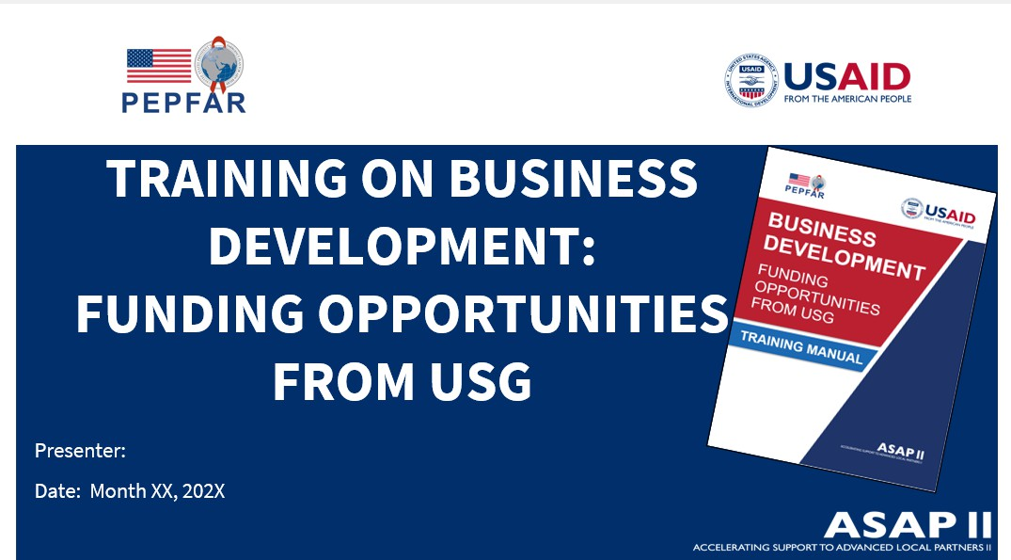
- Slide #2 (Overview of the training agenda/schedule)
- Briefly introduce the ASAP II program and summarize its goal and strategic objectives as shown in Slide #3 and explain that this training is based on The Business Development Training Manual produced by the USAID/PEPFAR-funded ASAP II.
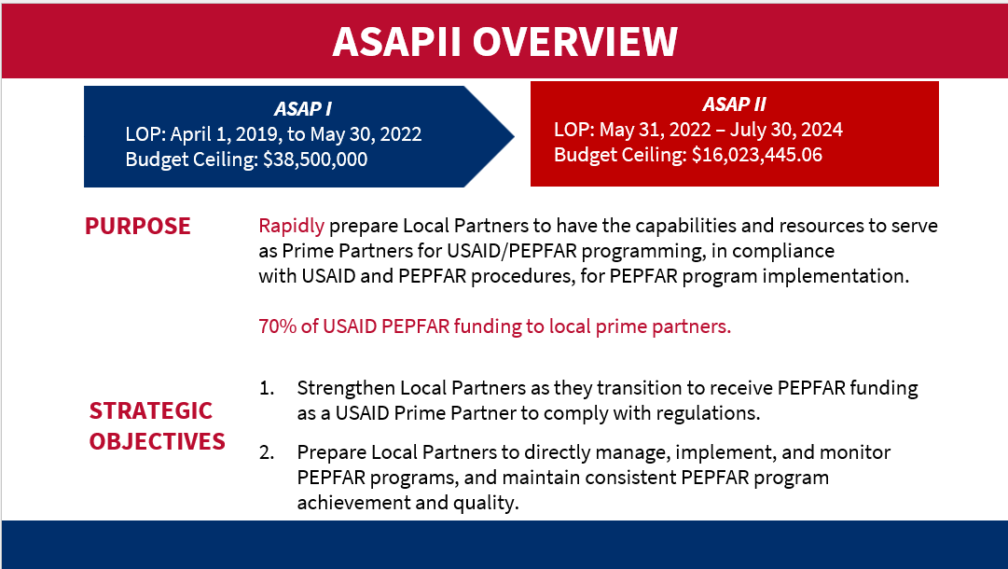

M 1.3: Participant and Facilitator Introductions and Expectations
Purpose: In addition to its social value, this activity will set the tone and atmosphere of the workshop, especially if done in a fun and interactive manner that enables participants to get to know one another both

from professional and personal perspectives. In addition, it gives the facilitator(s) insight into the participants’ needs, interests, and priorities and provides an opportunity to manage their expectations about what the training will cover and can feasibly achieve.
Upon completion of this training, participants will have:
  - Increased their awareness of how the USG announces and solicits applications or proposals for funding opportunities, with a focus on USAID and PEPFAR.
  - Improved their understanding of the proposal development process from pre-solicitation (capture) to post-submission (donor feedback and after-action reviews) – with a focus on solicitations from USG funding agencies such as USAID.
  - Strengthened their knowledge of key considerations, components, and criteria of successful proposals for USG-funded international development programming.
Content: Participants and facilitator(s) introduce themselves – including their name, preferred pronouns, title, organization, and country – summarize their BD experience, and briefly explain what they hope to get out of this training.
Delivery mode/activities:
- Start by having in-person participants create name tags to wear (on stickers) or place them on the table in front of where they sit (on folded paperboard); ask online participants to make sure their name and preferred pronouns are displayed and have them turn on their cameras.
- The facilitator introduces his/herself first, modeling the way that each participant will then do the same.
- Ask each participant to introduce themselves (name, preferred pronouns, title, organization, and country) one at a time, then summarize their BD experience (beginner, average, advanced), and briefly explain what they want to get out of the training (i.e., key skills/knowledge they would like to acquire and/or top priority topics they would like to cover).
- While they list expectations, the facilitator captures them on the flipchart paper (if it is an in- person training) or if a virtual training uses the available whiteboard or note taker. Remember to retain this list, as it’ll be shared on the last day, for the participants to assess the extent to which their expectations were met.

M 1.4: Training Agenda, Norms, and Housekeeping Information
Purpose:
  - To provide participants with the necessary information to be available when needed as well as actively and effectively participate in the sessions.
  - To create an enabling environment for a successful workshop.
Content: Present an overview of the training agenda/schedule, agree on norms that everyone will adhere to for the duration of the training, and share basic logistical/practical information on the venue or online platform.
Delivery mode/activities:
Agenda/Schedule – (Slide #2)
  - Briefly walk through the agenda, pointing out the daily start and stop times as well as the schedule for breaks and meals.
WHO SHOULD PARTICIPATE IN THIS TRAINING?
• Board Members
• Executive Directors
• Program/Project Directors
• Technical Staff
• Finance Staff
• Monitoring and Evaluation Staff
- Training Norms
  - Solicit ideas from participants on the training norms that will be agreed upon for the entire training; these typically will include
  - Starting and ending on time
  - No distractions like cell phones
  - Being inclusive and giving everyone a chance to participate equitably
  - Keeping cameras on for virtual participants, etc.

Type/write them up and post them in a visible location, reminding participants of them each day. The group might even agree on a funny way to sanction someone who doesn’t adhere to the norms, i.e., they must do a dance or sing in front of the group if they are caught talking on the phone or if they arrive late.
  - If the participants themselves don’t mention active participation and peer learning, the facilitator should add that to the list. Mention that you will be sharing tips and tools that can help them with BD, but that many of the participants have some BD experience and therefore everyone is encouraged to actively participate to learn from one another and discuss practical, contextually relevant examples.
- Housekeeping information
  - For in-person events, briefly share any important housekeeping information like where bathrooms are located, where refreshments and meals will be served, Wi-Fi log-in details, etc.
  - For online events, this is also an opportunity to explain how to use the online platform – such as the White Board/Annotation tool, breakaway groups, polls, etc. Also, be sure to get everyone’s consent to record the sessions.

M 1.5: Training Objectives
Purpose:
- To ensure that everyone understands what the training aims to achieve and how the training will be delivered.
- To manage participants’ expectations about what the training will cover and aims to achieve.
- To get the participants interested in and committed to the training.
Content: Present the training objectives and high-level program, manage expectations of the participants in terms of what can feasibly be covered and is within the scope of this training.
Delivery mode/activities:
- Summarize the Training Objectives (Slide M 1.1/#2), while projecting the slide that shows these.

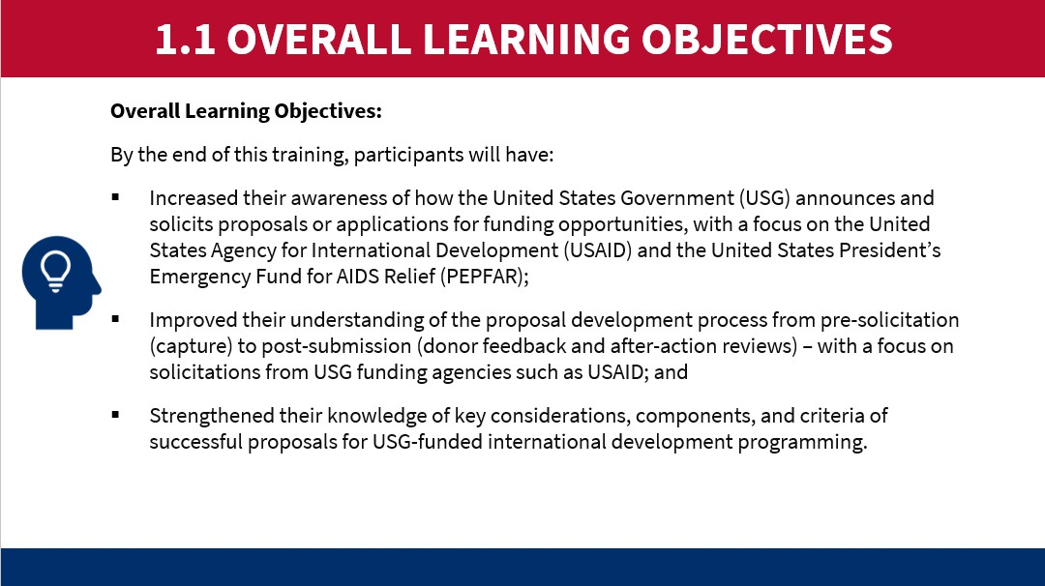
- While doing this, refer to the hopes/expectations that the participants just expressed, pointing out those that will definitely be covered, those that are outside of the training’s scope and therefore are not feasible to be tackled by this training, and those that might be covered or partially covered (depending on time, etc.)
- In conclusion, state that: “Ultimately, this training should better position your organization to successfully pursue opportunities for funding from USG Agencies such as USAID. The ultimate goal is to advance locally-led development (LLD) and increase the amount of USG development funding going to LIPs like you. We hope to see you all becoming USG Prime Recipients with stable and diversified funding streams for the long-term sustainability of your organization.”
- Ask with enthusiasm, “How does that sound to you?!” Try to garner up some clapping, positive emojis/GIFs (for online participants), and enthusiastic energy among the participants, to get them excited for the training and mentally committed to actively participating in all upcoming sessions.
- You can also use this opportunity to ask a few people to share their concerns and major challenges vis- à-vis BD. This can be helpful as an initial needs assessment; it also sets the stage for participants to know that this is a safe and supportive place where questions are welcomed, and everyone is here to learn.

M 1.6: Training Curriculum Organization
ASAP II has developed a BD webinar that has been delivered to LIPs in multiple languages, and this training program features content and slides from that webinar series. Below is an outline of the modules and topics covered (Relevant Slides M 1.2/#3-4):

INTRODUCTION
ASAP II Overview and Introduction to the Business Development Training
MODULE ONE: TRAINING OPENING/INTRODUCTION
1. Setting the tone of the training
2. Laying out the preparatory measures, ground rules, training delivery methods, training objectives, and expected outcomes, how the manual and training curriculum are organized, and instructions for participant assessment
MODULE TWO: OVERVIEW OF BUSINESS DEVELOPMENT
1. Business Development/Proposal Development in the Context of USG Funding
2. Overview of Mechanism and Process for Issuing USG Funding
MODULE THREE: PRE-SOLICITATION PREPARATION
1. Identifying funding opportunities
2. Deciding whether to pursue the opportunity
3. Capturing the opportunity
4. Forming a winning consortium
MODULE FOUR: LIVE PROPOSAL KICK-OFF
1. Getting organized
2. Understanding the donor and requirements of the solicitation
3. Proposal Kick-off Meeting
4. Preliminary steps before winning the proposal
MODULE FIVE: PROJECT DESIGN AND TECHNICAL AND BUDGET PROPOSAL DEVELOPMENT
- Project Design and Proposal Development
  - Technical Proposal
  - Cost Proposal
2. Tips and Considerations for Strong and Compliant Proposal Package
3. Proposal Review and Editing
4. Proposal Finalization and Submission
MODULE SIX: POST-SUBMISSION
1. Post-Submission Actions
2. Learning from the experience

M 1.7: Delivery Approach (Facilitator’s/Trainer’s Notes)
A PowerPoint (PPT) presentation deck accompanies this manual, to provide the facilitators/trainers with additional details and materials to share with the participants. This manual also offers session plan ideas in the section below, which the facilitator/trainer may elaborate or revise to suit the audience, delivery type (in-person, virtual, or blended), and amount of time available for the training.
This training manual and the slides offer the underlying content for the BD training, yet they are not prescriptive about lesson plans and how each session is delivered. As a facilitator, you will be responsible for creating a learning space in which participants feel comfortable engaging, questioning, and participating fully in the training process. It is vital to create an environment that is comfortable, and trusting and provides a safe space for the participants to share and learn from each other’s ideas and experiences, keep an open mind, and form a consensus on the specific BD topics and related issues discussed in each session. This will be achieved by investing time and effort into planning for each session and utilizing participatory facilitation skills that promote mutual respect, reflection, and active participation.
The more interactive and practical the sessions, the more effective learning will be. We encourage you to use case studies, present real examples, and draw from the experiences of the participants. However, recognizing that BD can be a sensitive topic since the different participants might come from organizations to compete with one another for the same funding opportunity. With this in mind, a certain level of trust and confidentiality will need to be fostered for the success of the workshop.
It is recommended to intersperse question and answer (Q&A) sessions periodically throughout the training. That will help participants ask questions and allow facilitators to clarify misunderstandings and highlight priorities and key considerations.
Occasional icebreakers can help participants get to know one another and start fostering an atmosphere of trust and openness, which is important for any training but especially for BD which can be a competitive and sensitive topic. Energizers are also a good way to keep the participants alert and engaged, especially after sessions that feature the presentation of numerous PPT slides.

M 1.8: Participant Assessment
To assess learning outcomes resulting from the completion of this training, trainers can compare pre-test and post-test results. They can also examine the participants’ feedback in the post-course survey.
Pre-test Assessment
The pre-test is included in the annex and can be administered online (via Survey Monkey or Google Forms) at the onset of the course or in paper handouts at the start of a face-to-face training workshop. The pre-test should cover all sections of the BD training. Have participants quietly and independently answer the question for approximately 10 minutes; be sure each participant specifies their name, organization, and country on the test.
Post-test Assessment
A post-test should be administered in the same way as the pre-test, to enable comparisons of like against like.
Training Survey:
A questionnaire soliciting feedback from the participants on the content, quality of the trainers/facilitators, and delivery methods is recommended. Informal feedback can be gathered daily, or a more formal survey can be conducted at the end of the training. The purpose is to gauge levels of satisfaction and seek recommendations for improvements to future training that use this manual and the accompanying presentation slides.

MODULE 2: OVERVIEW OF BUSINESS DEVELOPMENT
Learning Objectives (Relevant slide: M 2.0/#2)
- Acquire a basic knowledge of key terms and concepts around BD and proposal development.
- Understand the types of funding opportunities that PEPFAR/USAID and other USG agencies tend to release that are eligible for LIPs.
- Be aware of the main components of the solicitation/proposal development process.

M 2.1: Business Development/Proposal Development in the Context of USG Funding for LIPs
Relevant slides: M 2.1/#3-5
Purpose:
- Set the context for this training.
- Reiterate the importance and relevance of this training to the LIP participants.
- Clarify key terms and concepts that are fundamental for this training.
Content:
- Contextualize this training, highlighting the latest trends in the USG funding landscape with the increased prioritization of LLD and greater amounts of funding going directly to local organizations.
- Explanation of key terms and concepts, including the difference between BD and proposal development.
Delivery mode/activities:
- Conduct an online poll (in MS Teams, Zoom, etc. for virtual participants) or ask in-person participants to raise their hands to indicate which LIPs attending the training:
  - Have been or are you currently prime recipients of USG funding?
  - Have been or are currently subrecipients of USG-funded awards (for instance, a project with an INGO as prime recipient)?
  - Have applied directly for USG funding via a competitive procurement process?
- Ask participants what their impressions are of the current funding landscape for LIPs. Probe about whether they have noticed increased funding going to LIPs in their country, what LLD means to them and how it has been affecting them (if at all), and the extent to which they are familiar with USAID’s relatively new Local Capacity Strengthening (LCS) Policy, the previous PEPFAR localization targets, and the USG LLD agenda. (The aim is to simply get a bit of a conversation going, to set the stage for this training, to get the participants engaged, and to gauge their level of understanding of the current context of USG funding priorities.)
- In facilitating that conversation, use Slide M 2.1/#3 as a guide to offer complementary information on USG funding opportunities for LIPs, if needed depending on what points are raised in the plenary.

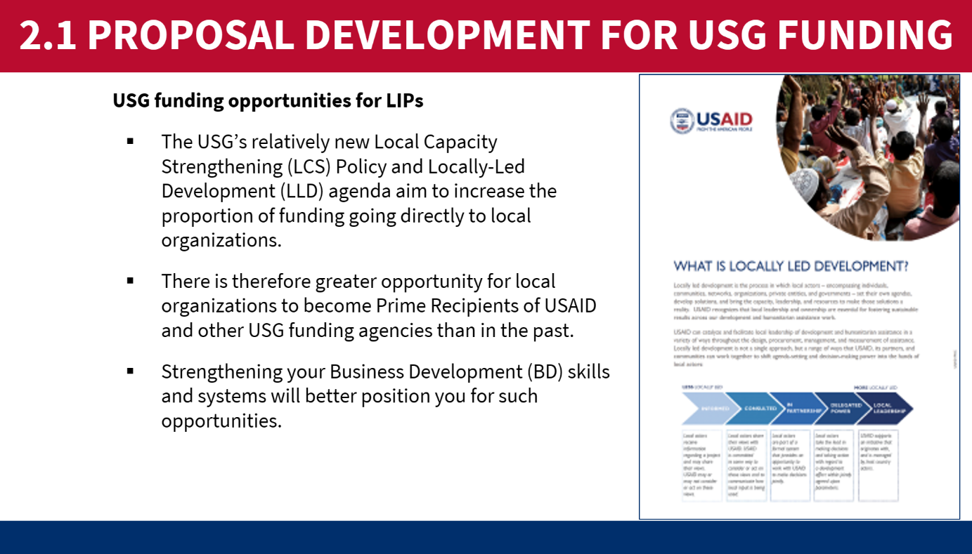
- Point out that participants may hear many different terms that are related and generally refer to the same basic concepts: Business Development, Resource Mobilization, Fundraising, Proposal Development, etc. Ask for a few volunteers to share their thoughts on how to define these terms and what the slight differences might be.
- In responding, you can point out that BD, resource mobilization, and fundraising generally refer to the same thing. Proceed to present Slide M 2.1/#4, which explains the definition of BD. Key points to emphasize are as follows:
BD supports organizations to maintain and grow their presence and impact in addressing critical challenges. It is also critical to USAID and other USG funding agencies for program development and implementation, as the proposal process helps donor agencies identify strong implementing partners.
- Then point out that proposal development is certainly related to BD, yet it is less broad. It is a BD method, among other methods. Then proceed to explain the contents of Slide M 2.1/#5, which defines proposal development.
  - NOTE: If a participant enquires about other BD methods (apart from proposal development), the facilitator can toss the question back to the participants to offer their ideas and give examples of other methods their organization might have used to maintain and grow their organization. If needed, you can share examples such as income-generating activities (IGAs) that are reinvested in the organization, fee-based services (e.g., consulting/contracting work), strategic partnerships that lead to business, non-competitive opportunities, proactive preparation and submission of concept notes, etc.

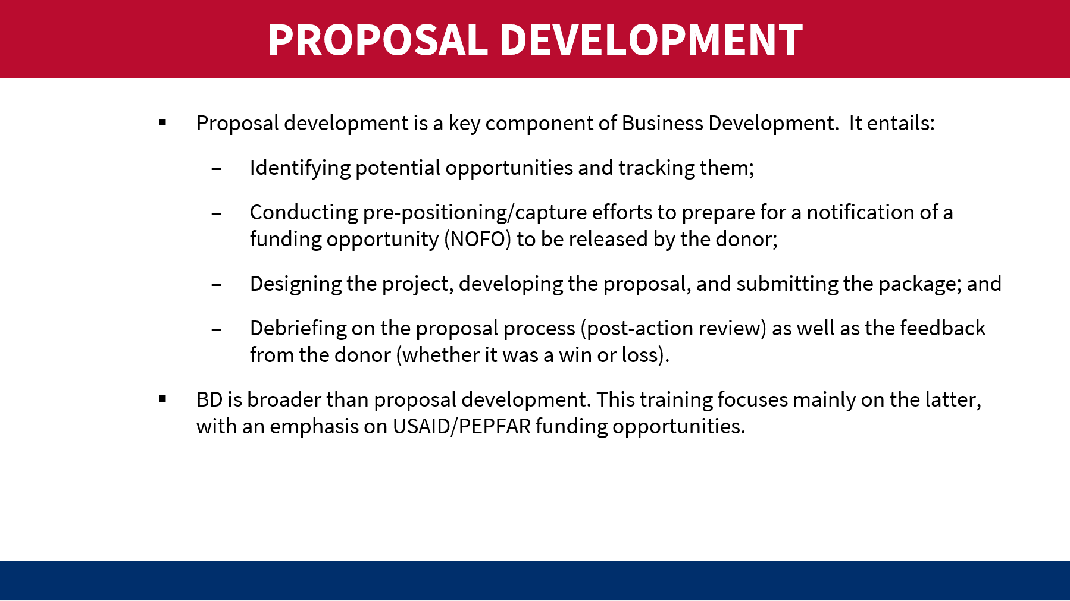

M 2.2: Overview of Mechanism and Process for Issuing USG Funding
Relevant slides: M 2.2/#6-11
Purpose:
- To get a common understanding of key terms and processes.
- To introduce the main phases of the process, pointing out that this training is organized by those phases and will go into more detail on each of them during the subsequent modules (transition to the third core module).
Content:
- Non-competitive awards with a focus on the Transition Award.
- Different kinds of solicitations for funding e.g., Notice of Funding Opportunities (NOFOs), Request for Applications (RFA), and Request for Proposals (RFPs).
- Overview of the main phases of the procurement process.
Delivery mode/activities:
- Present each point in Slide M 2.2/#6 one-by- one.
  - Ask volunteers to explain what difference they understand between a Request for Information (RFI), a Request for Applications (RFA), and a Request for Proposals (RFP).
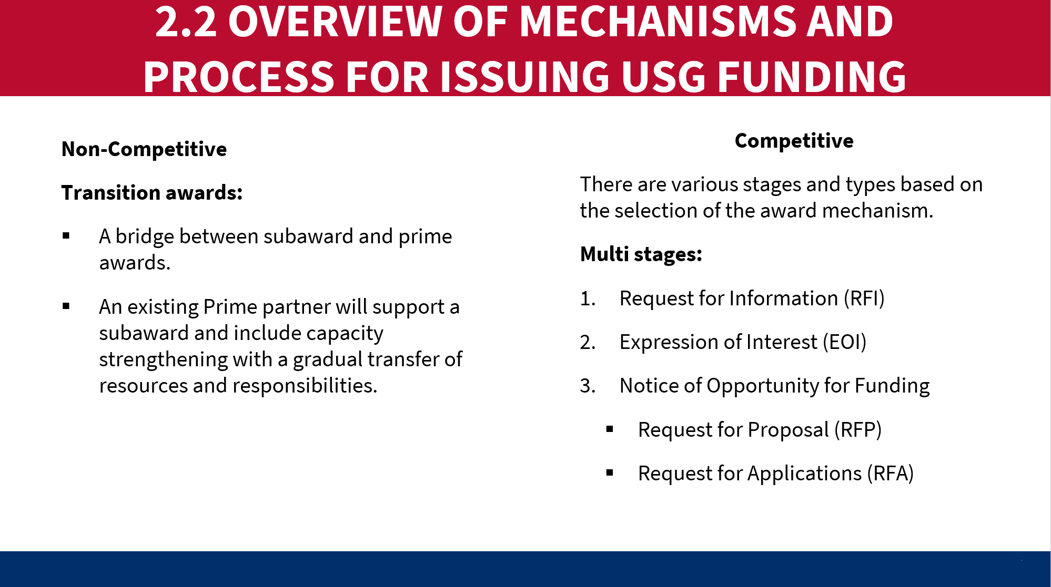
- Then proceed to the following slides (Slides M 2.2/#7-11) to explain the award mechanisms and process, and the occasional situations where the donor uses a multi-stage solicitation process to do an initial shortlisting of candidates that will be eligible to apply for the full proposal (via an EOI/RFI). However, point out that many procurements are issued directly as an RFA/RFP, without the initial Concept Note stage.
- Finally, present Slide M 2.2/#12, which explains the solicitation/proposal process and phases and points out that each phase consists of various steps. Explain that this training is organized according to those phases, with each detailed in separate modules.

* This can be a good moment for a break, if needed/appropriate. *

MODULE 3: PRE-SOLICITATION PREPARATION
Learning Objectives:
- Be aware of various sources of funding and be able to access existing USG resources to identify opportunities.
- Understand the key considerations for “go/no-go” decision-making.
- Appreciate the need for early preparation for solicitations and how pre-positioning/capture work can increase your chances of a successful proposal (at the next stage), and
- Be better positioned to form a winning consortium.

M 3.1: Opportunity Identification
Relevant slides: M 3.1/#1-8
Purpose:
- To increase participants’ awareness of sources of information on opportunities.
- To enable participants to take practical steps to follow funding opportunities.
- To emphasize the need to track opportunities for which they are eligible (i.e., open to LIPs).
Content:
- Where and how to identify potential funding opportunities from USAID & other USG agencies.
- Introduction to the USAID Business Forecast, www.grants.gov and www.SAM.gov.
- Eligibility considerations.
Delivery mode/activities:
- Brainstorm sources of opportunity information:
  - For in-person participants: Quickly pair them up with the person sitting next to them and give them a few minutes to jot down ideas on where/how they could find out about potential funding opportunities from USAID and other USG Agencies (CDC, DOD, BHA, etc.).
  - For virtual participants: Ask them to type into the online White Board (using the Annotate tool in MS Teams, for instance) their individual ideas on where/how they could find out about potential funding opportunities from USAID and other USG Agencies (CDC, DOD, BHA, etc.). Tell them to only post ideas that others haven’t already posted (except of course for inevitable concurrent/cross-postings).
- Then project Slide M 3.1/#3- Ways to identify potential funding opportunities from USAID & other USG agencies and see if it has any additional ideas that the group didn’t identify; point those out (rather than reading the entire slide).

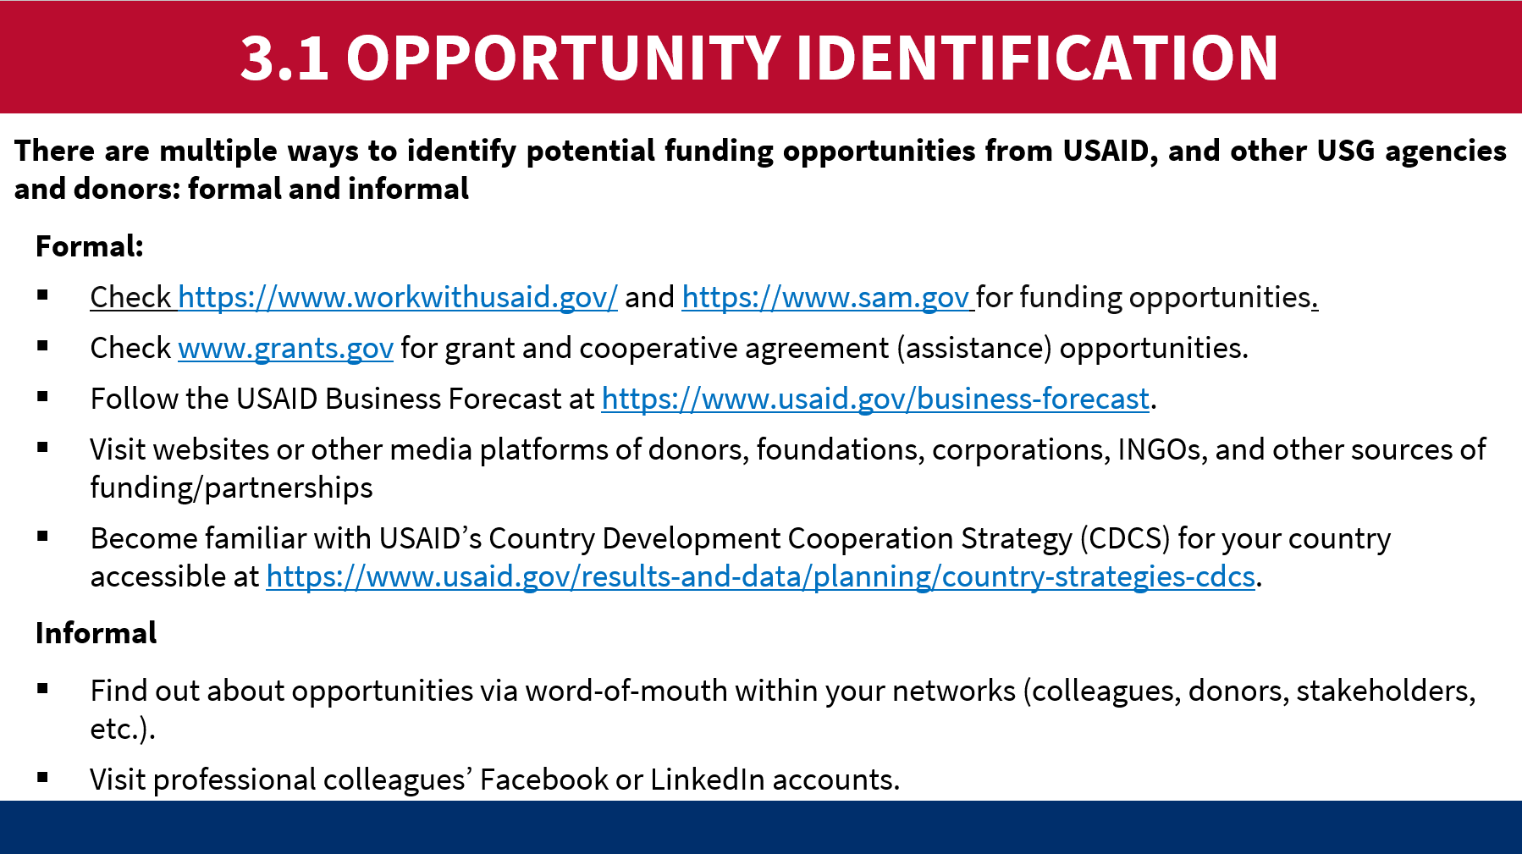
- Slides M 3.1/#4-5 explain the USAID Business Forecast and Slide M 3.1/#6 presents the www.grants.gov website and Slide M 3.1/#7 presents www.sam.gov, as each are important source of information on USG funding opportunities. Encourage the LIPs to subscribe (if applicable) and monitor these sites on a regular basis (daily, as every day matters when a proposal goes live!). If possible, go directly to the websites (rather than just projecting those slides, given that the font is quite small) and do a quick demonstration of how to find the relevant information and subscribe to the business digest emails.
- Hands-on practice using USG online platforms:
  - If time allows and if all participants have access to the internet, divide up the groups (having in-person participants work a different table with 3-4 team members or using “breakout groups” in online apps such as MS Teams, Google Meet, or Zoom for virtual participants). Assign a group the task of searching the USAID Business Forecast to find potential opportunities of interest in their country; and assign another group the task of searching www.grants.gov, and a third group to exploring www.sam.gov.
  - Don’t take time to do group-by-group plenary debriefs (that would be time-consuming), yet you could ask a few volunteers to share some observations about what they found and/or how helpful they feel these platforms are.
- Use Slide M 3.1/#8 to briefly discuss eligibility – i.e., the fact that all USG solicitations will specify what kind of organizations can apply; and they should only spend their time tracking and pursuing opportunities for which they qualify and ones that they have a strong chance of winning. Also, point out the requirement of getting a unique entity identifier (UEI) number via SAM.gov.

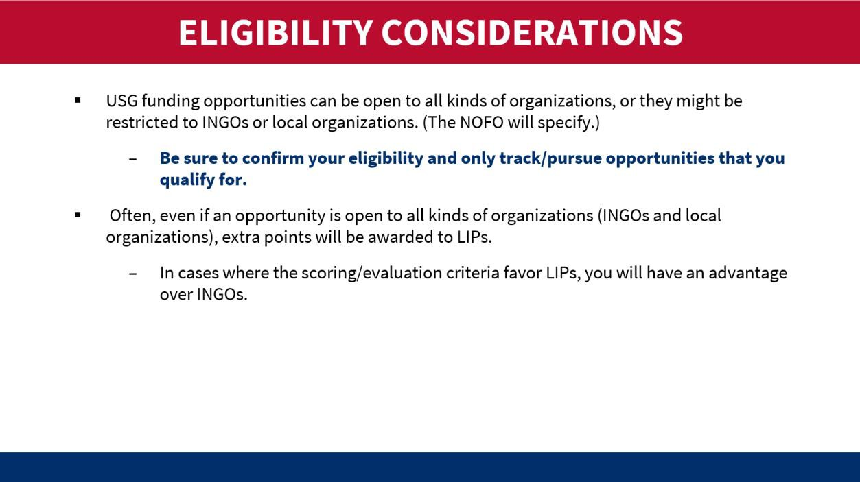

M 3.2: Deciding Whether to Pursue the Opportunity
Relevant slides: M 3.2/#9-10
Purpose:
- To increase appreciation of the need for prioritization and strategic approaches to deciding on which opportunities to pursue.
- To offer a set of key considerations/criteria for making a “go” or “no go” decision.
Content:
- Importance of prioritization of opportunities that an organization pursues.
- Key considerations to make a “go” or “no go” decision on applying as a prime partner versus looking for a subaward opportunity.
Delivery mode/activities:
- Use Slide M 3.2/#9 to emphasize the importance of prioritizing which opportunities an organization pursues.
  - You could start (before projecting the slide) by prompting some reflection and initial discussion in plenary by asking the group:
Let’s say you identified several opportunities in the USAID Business Forecast that your organization qualifies for and that will be released around the same time. Great news! But will you be able to pursue all of them? Does it make sense to pursue all of them?
  - After taking a few answers, make the following point: Although it may be tempting to try to go after all of them (especially if you’re seeking to diversify funding sources and expand your portfolio) –you need to be realistic about under what conditions you can produce a high-quality proposal that is likely to win.
  - Then share the key take-aways from the PowerPoint (PPT) slide.

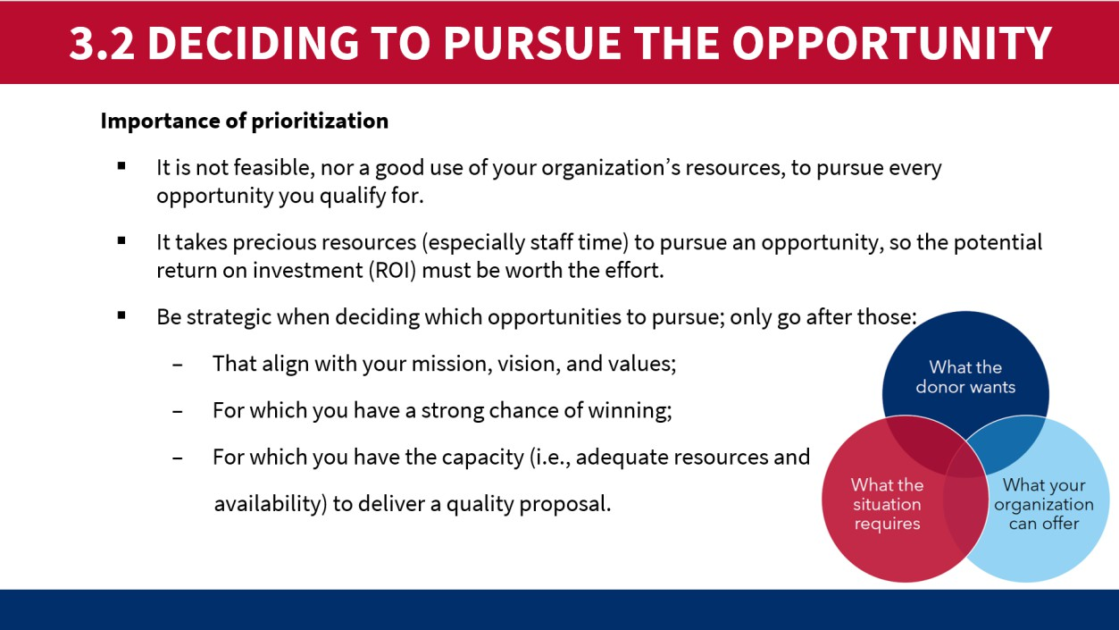
- Key considerations to make a “go” or “no go” decision, Slide M 3.2/#10
  - Ask participants to share their experiences they had when deciding not to go for a proposal. What were the main factors? Ask participants to share the experiences they had when deciding when to move forward with submitting a proposal. What were the main factors?
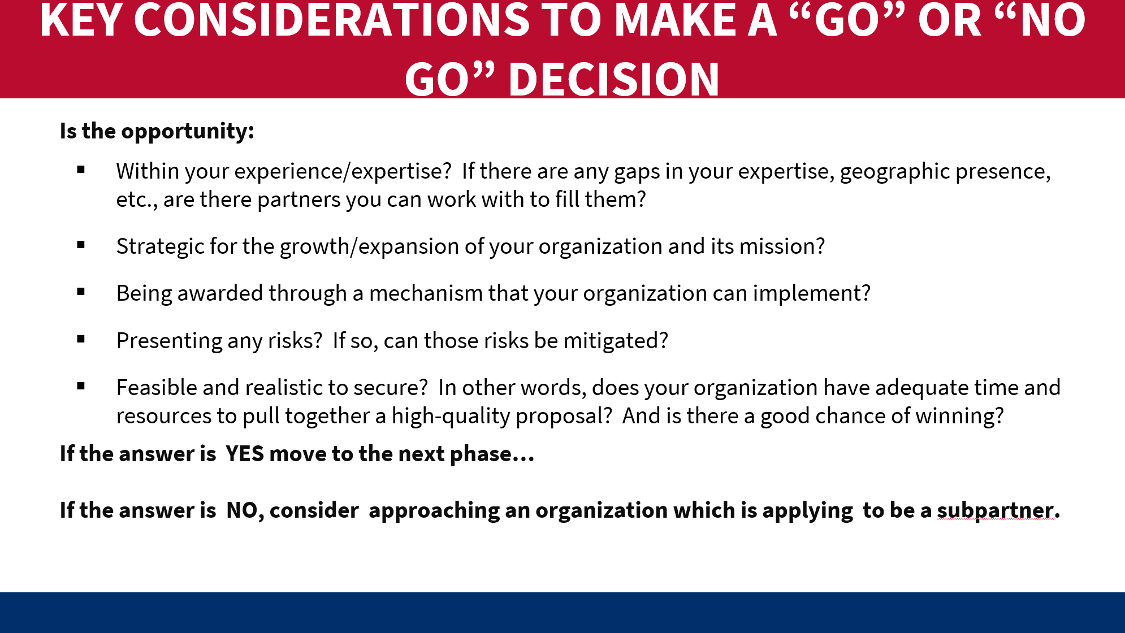

M 3.3: Pre-Positioning/Capture Work

Relevant slides: M 3.3/#11-13
Purpose:
- To emphasize the importance of early preparation and pre-solicitation activities.
- To highlight good practices for pre-positioning/capture work.
Content:
- Introduction to pre-positioning/capture work: What is it? What does it consist of? Why do it?
Delivery mode/activities:
- Before projecting any slides, ask the participants “Now that your organization has decided to go for a certain opportunity, what should you do next? Do you simply wait for the NOFO to be released?” Take a few answers in plenary. Then emphasize the points on Slide M 3.3/#11, i.e.:
Once the donor releases the call for applications/proposals, the clock starts ticking! Solicitations are typically open for only 30 to 45 days (4 to 6 weeks), so it is important for applicants to anticipate and prepare for the solicitation as much as possible before it goes “live”. USAID typically announces upcoming solicitations in its Business Forecast, and there are other ways to get information on forthcoming opportunities. LIPs should be ready to develop and submit their proposal when the funding opportunity is issued, having done some preparatory work in advance.
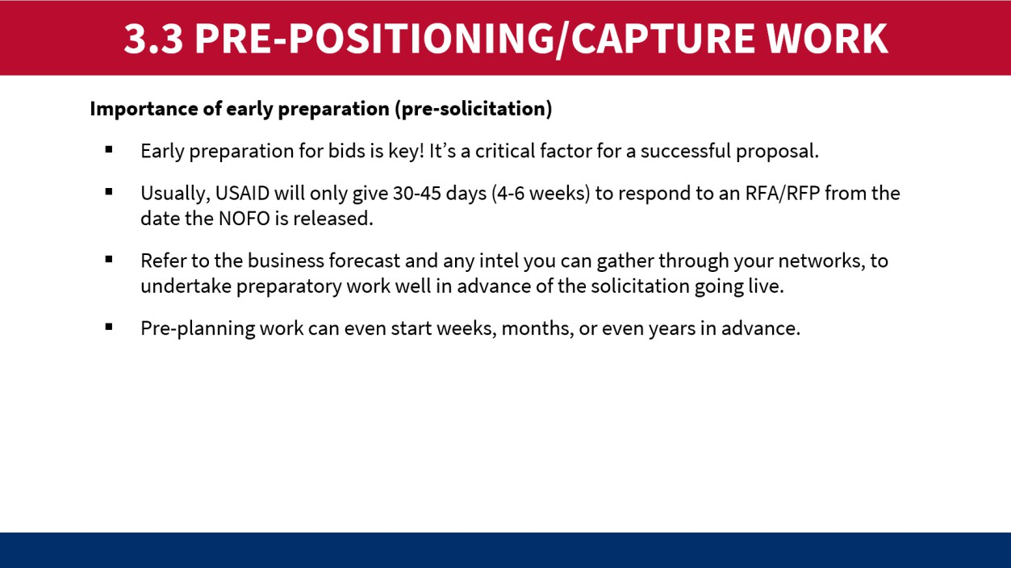
- Then ask the participants, “Who has experience undertaking capture work, otherwise called pre- positioning” or “pre-planning”? For those who raise their hand, call on a couple to explain what it is or what key activities they have been involved in.
- Project Slide M 3.3/#12 to elaborate on the purpose and elements of pre-positioning/capture work, and how the information gathered will inform subsequent processes.

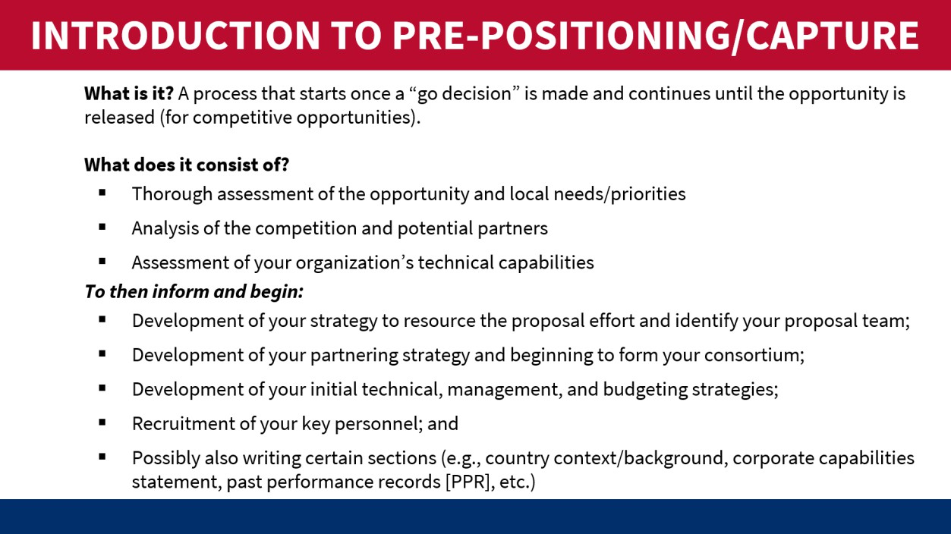
- For Slide M 3.3/#13, either explain the example on the slide or ask the participants who have the experience to share a couple of real examples. If time allows, it’s best to do the latter as it’s more engaging for the participants to be actively involved rather than lectured to.

M 3.4: Forming a Winning Consortium
Relevant slides: M 3.4/#14-21
Purpose:
  - To clarify expectations of project partnerships on USG-funded proposals.
  - To be aware of the types of partners that the Prime recipient could consider.
  - To understand how to identify potential partners for the proposal and the process for forming the project team/consortium, and
  - To learn of some documents/tools that are used for partnership formation, including PTAs and TAs.
Content:
  - Typical partnership arrangements on USG-funded proposals.
  - How to identify potential partners.
  - Considerations for partner selection.
  - Documents/tools to support partnership formation.
  - Process for forming the project team.
  - Information on Pre-Teaming Agreements (PTAs) and Teaming Agreements (TAs).
Delivery mode/activities:
- Using Slides M 3.4/#14-20: Walk through the different steps in creating a consortium.

Very few organizations can provide all the services required in a NOFO. Typically, a strong organization will decide to become a Prime and start looking for other organizations to become sub-partners in a consortium (Slide M 3.4/#14). The proposal will want to capture a “one team approach” and will need to demonstrate that in both the program areas and management structure. It is important not to have too many and to have clearly defined roles.
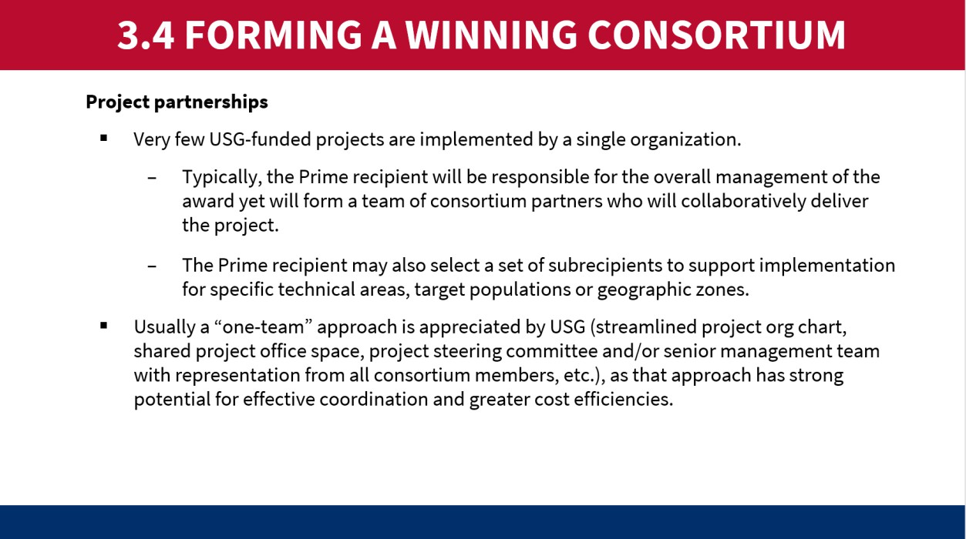
- At the end of presenting Slide M 3.4/#15 (HOW TO IDENTIFY POTENTIAL PARTNERS?), ask participants what important considerations are for choosing consortium members, as shown in Slide M 3.4/#16 below.
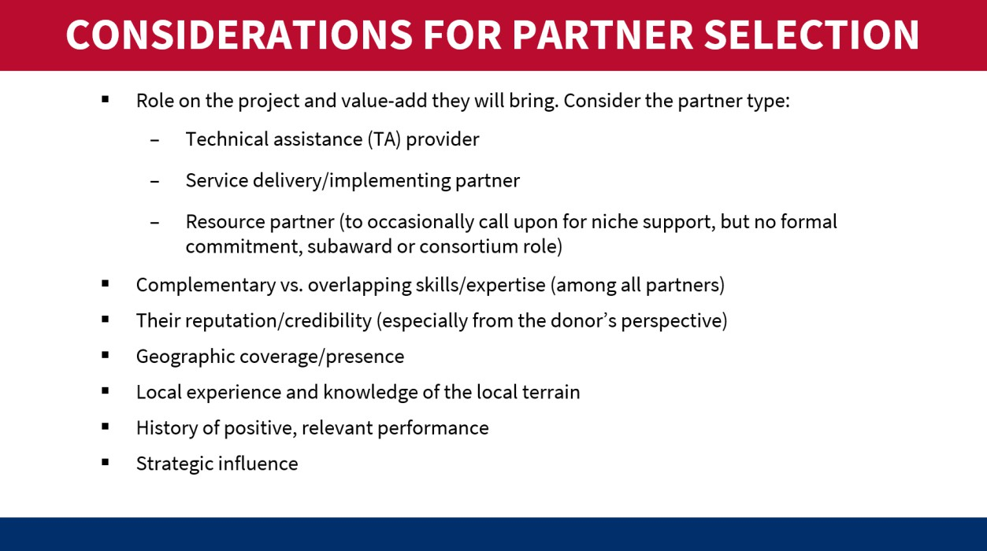
- Proceed to Slide M 3.4/#17 to explain the process for forming the project team.
- Slides M 3.4/#18-21: There are four important documents to request or develop as part of the consortium building.

  - A Capability Statement: Ask the potential consortium member to submit a Capability Statement based on their organizations’ experience in the technical and geographic areas in the proposal.
  - Pre-Team Agreement: This document precedes the proposal release and articulates the intention of both parties. It is important to only use a pre-agreement as the final proposal may change the Disclosure Agreement: Ask the potential partner to sign an NDA which prevents them from using the information you share about proposal preparations with anyone else.
  - Non-Disclosure Agreement: Ask the potential partner to sign an NDA that prevents them from using the information you share about proposal preparations with anyone else.
  - Scope of Work: Design a SOW that aligns with the proposal and the organization's Capacity
Statement.
Hypothetical Scenario
As shown in Slide M 3.4/#21, an NGO named CareServices (CS) wants to prepare a proposal for a USAID solicitation named “Expanding HIV/AIDS Care and Treatment in (you can name a country where the training is being held). CS works in the capital and two other large cities. The proposal needs to include geographic coverage where they do not work. An NGO named EqualAccess is based in half of the districts in the country.
Player 1: Executive Director for CS
  - Wants EqualAccess to join the consortium and not sign up with another consortium.
Player 2: Executive Director for EqualAccess
  - Has other offers to join different consortiums. Wants to understand the scope of work and how CS manages sub-partners.

MODULE 4: LIVE PROPOSAL KICK-OFF
Learning Objectives:
    - To be aware of the process and key tools for project design and proposal development.
    - To understand the requirements and best practices for developing a strong proposal package (technical and cost proposal), and
    - To appreciate the importance of conducting multiple, thorough reviews and edits as well as packaging and submitting the proposal on time.

M 4.1: Getting Organized
Relevant slides: M 4.1/#1-7
Purpose:
  - To highlight the most urgent first actions to undertake once the proposal is live.
  - To offer some tips and tools to get organized and quickly mobilize the proposal team.
Content:
  - Immediate steps to take once a solicitation is released, and
  - Tips and tools to get organized.
Delivery mode/activities:
- Project and read aloud Slide M 4./#3, shown below:
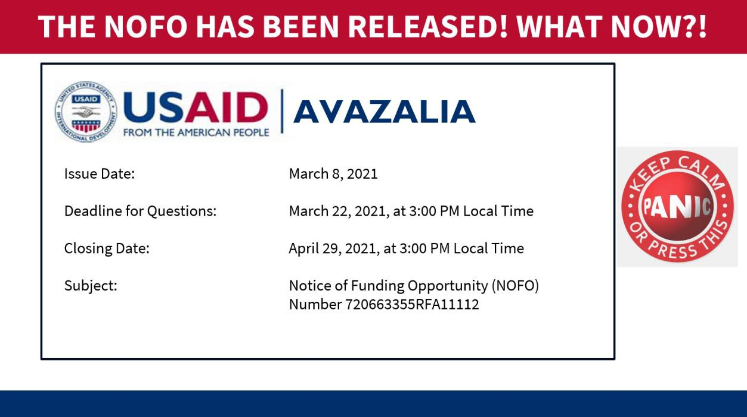

- You can also hand out or show them the image shown below, which is an example of a NOFO cover page, or you can share a recent NOFO from the country where the training is happening. Take a few people’s answers to the question “What now?!”

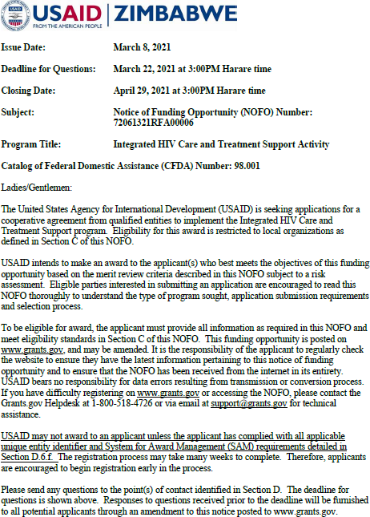
- Proceed to Slide M 4.1/#4, emphasizing that the clock starts ticking as soon as the NOFO is released, so they should not lose any time. Immediately, the assigned proposal manager needs to get organized and mobilize the proposal team as well as communicate key information to partners and reviewers so that everyone will be ready to take on their assigned role. As indicated in Slide M 4.1/#4, emphasize that the proposal manager should first and foremost make note of important dates/deadlines.
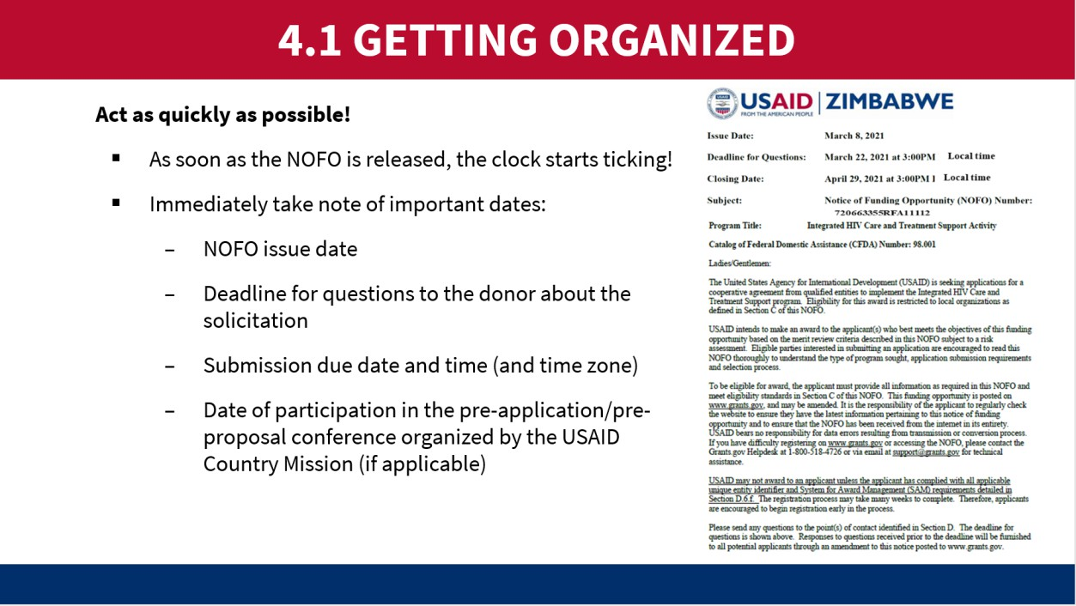

- Ask participants to quickly brainstorm a few ideas on what other key factors for successful proposal development are.
  - F2F participants can write their ideas on Post-It Notes (one idea per sticky note) and post them on a piece of flip chart paper at the front of the room.
  - Virtual participants can either write their ideas into the chat box or type them into an online white board (available in Microsoft Teams, Google Meet, and Zoom).
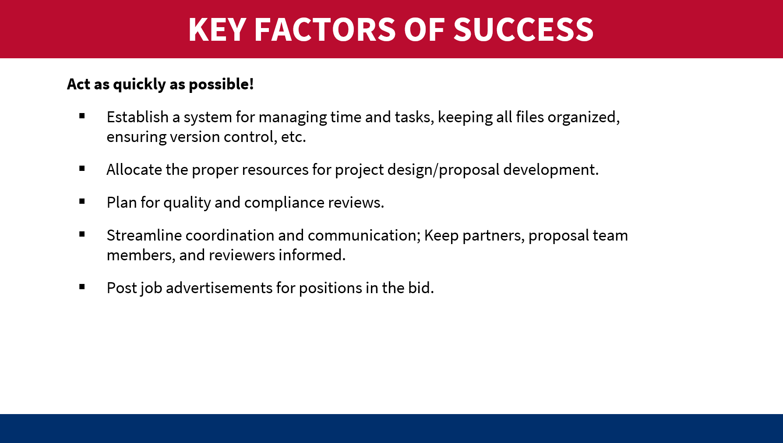
- Then project Slide M 4.1/#5, pointing out what we have identified are the most critical factors based on extensive experience. Note that they are mostly related to good organization and management of the process, so having a proposal manager/coordinator is critical.

- Moving to Slide M 4.1/#6, explain that an urgent task once the proposal goes live is to mobilize the proposal team. The members and reviewers would’ve ideally been identified in advance (during the Capture stage), but it’ll be important to confirm their availability and immediately inform them of all key deadlines. Use the slide to point out the different functions needed for an effective Proposal Development team as well as independent reviewers. Emphasize the most critical functions versus those that are just “nice to have.”
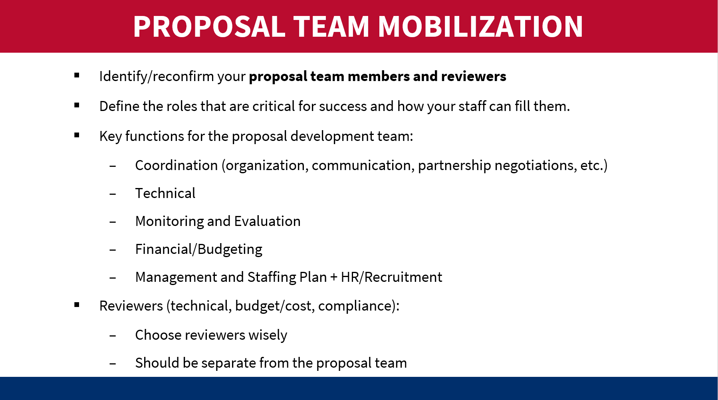

- Show participants the example BELOW of a real proposal calendar – distribute it as a handout to F2F participants or send it to online participants. Ask them to take a couple of minutes to individually look it over and jot down any notable observations. Did anything that surprised them or raised questions? Is there anything that they learned from this example? They might, for instance, point out that the proposal is planned to be submitted 2 days before the donor’s deadline and not understand why; or they might be surprised at how much time is allocated to review/editing, leaving a tight timeframe for proposal design and writing.
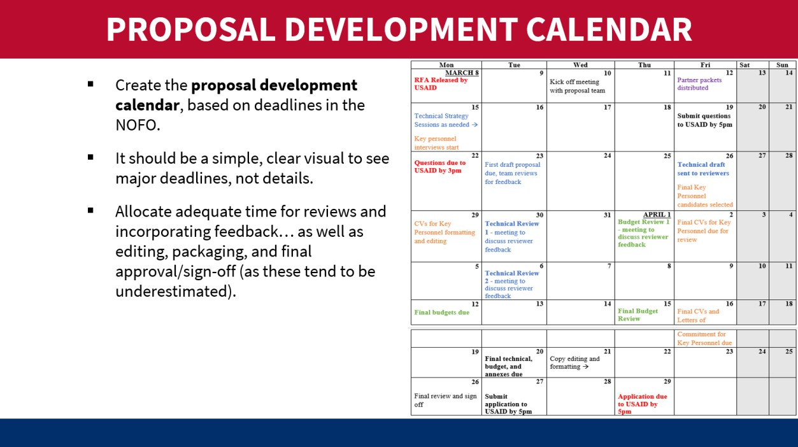

- While projecting Slide M 4.1/#7, emphasize the importance of developing a calendar for once or twice-a-week meetings during the Proposal Development process which takes into account the deadlines in the NOFO. The meetings should ensure technical components are aligned with staffing and management plans, budgets, and M&E plans. There should be a sufficient “cushion” for unexpected events and adequate time for review, editing, packaging, and final approval/sign-off (as those tasks tend to take much longer than one might expect).

M 4.2: Understanding Donor and Requirements of Solicitation
Relevant slides: M 4.2/#8-15
Purpose:
  - To emphasize the importance of reading and re-reading the solicitation and making sure that the proposal team understands the requirements, evaluation criteria, deadlines, etc.
  - To get familiar with tools to facilitate understanding and communicating about the NOFO.
Content:
  - Immediate actions to take once the solicitation goes live.
  - Common requirements/evaluation criteria of USG NOFOs.
Delivery mode/activities:
- Before projecting Slide M 4.2/#8, say to the group – that your proposal team is now formed, and your proposal calendar is done. Are you ready to jump right into proposal writing now?
- In response to those who say “no,” ask them what they think needs to happen next. What is the most critical next step?
- Share the answer by projecting Slide M 4.2/#8 (shown below). It’s reading, and re-reading, the entire solicitation document carefully and thoroughly!
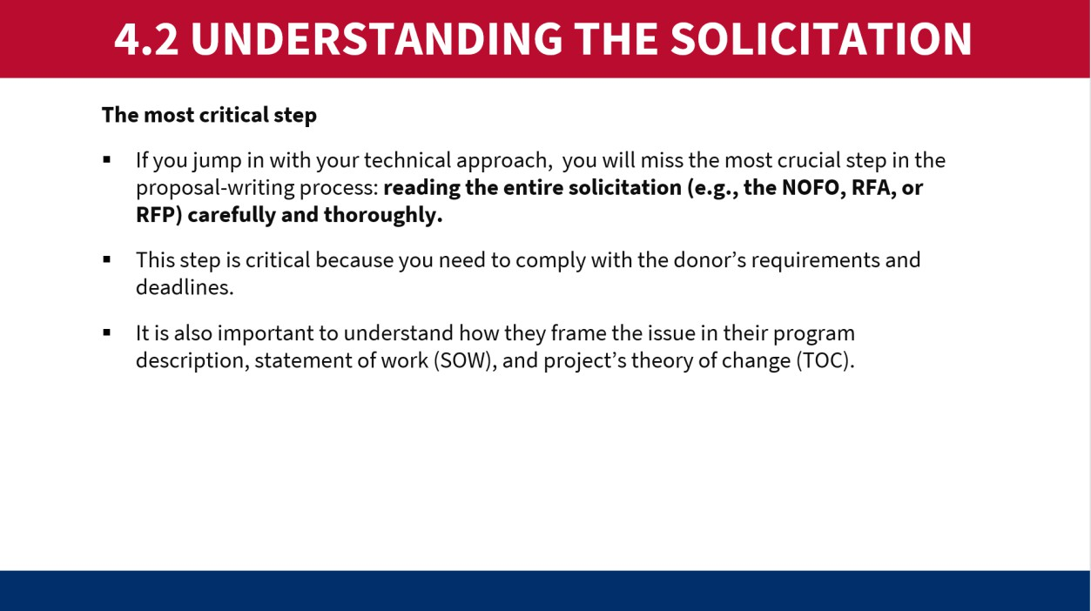
- After covering the bullets in Slide M 4.2/#8 (above), point out that:
  - The best-designed, well-written proposal can be disqualified simply because it has more pages than the allowable limit or because it was submitted one minute after the deadline. So, understanding the requirements of the solicitation and complying with them is absolutely critical!
  - It’s not just about compliance with the format, deadlines, and basic instructions. It’s also about making sure your proposed project is responsive to what the donor wants, so align it to their priorities and desired approaches, use their jargon so that you’re speaking the language they will understand, and do everything possible to score all

possible points (per the evaluation criteria) – for instance, clearly demonstrate how your Key Personnel meet their minimum requirements.
- Project Slide M 4.2/#9, reading out what they need to pay particular attention to in the NOFO/RFA/RFP document. Give the following example of how certain sections are weighted/scored:
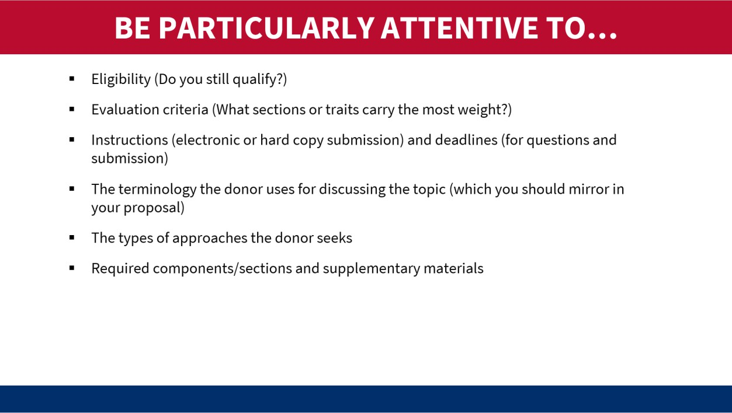
- As shown in Slide M 4.2/#10, in a particular proposal, USAID provided the following evaluation criteria for the technical proposal, which is quite typical of the way they weigh the different elements:
  - The technical approach (50 points)
  - Management and staffing (30 points)
  - Organizational capacity (20 points)
- Before showing the participants Slide M 4.2/#11 (below), have them pair up (or use virtual breakout rooms to create small groups) and give them just a few minutes to list every key section of a typical USAID proposal as well as the supplementary materials required in the Annexes. Once most of them have completed their list, have them check their own understanding by comparing what they wrote with the list on the slide.

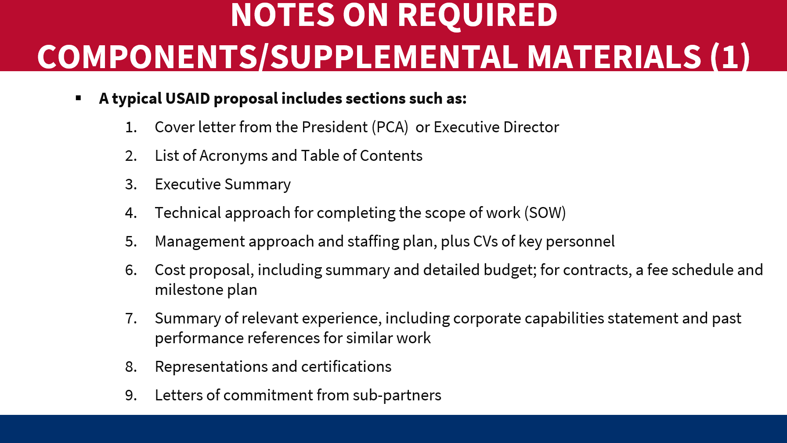
- Then present Slide M 4.2/#12-- some participants may have listed these as part of the proposal, and they are not necessarily wrong. In some cases, these items are required at the proposal stage, whereas in other cases they are post-award deliverables.
- Tell participants that it can be helpful to make a copy of the solicitation by hand or on a computer to track the key elements of the opportunity. Say that:
  - Some organizations create a “crib sheet” that strips the solicitation down to its critical components, forming a kind of checklist to help the team ensure that they have all the required elements – a Compliance Matrix can serve this purpose.
- Using Slides M 4.2/#13-14 as aids, explain the value of using a Compliance Matrix to capture the most important information from the solicitation document, and to share that information with the proposal team members and reviewers. Below is an example of a Compliance Matrix; you can distribute it since the image in the slides may not be easily legible to the participants.
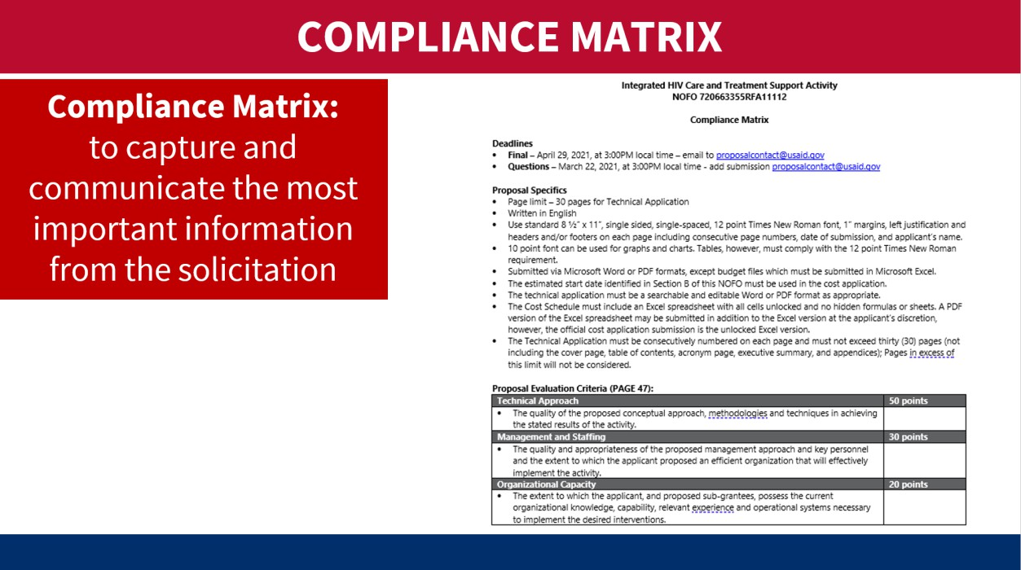

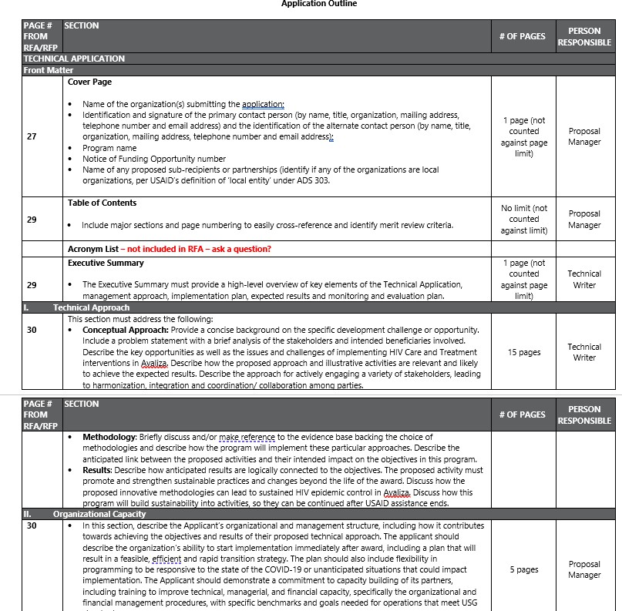
- Finally, wrap this session up with Slide M 4.2/#15 (below) highlighting that many organizations will require a final “go decision” confirmation from leadership before the proposal team can proceed with project design and proposal development.
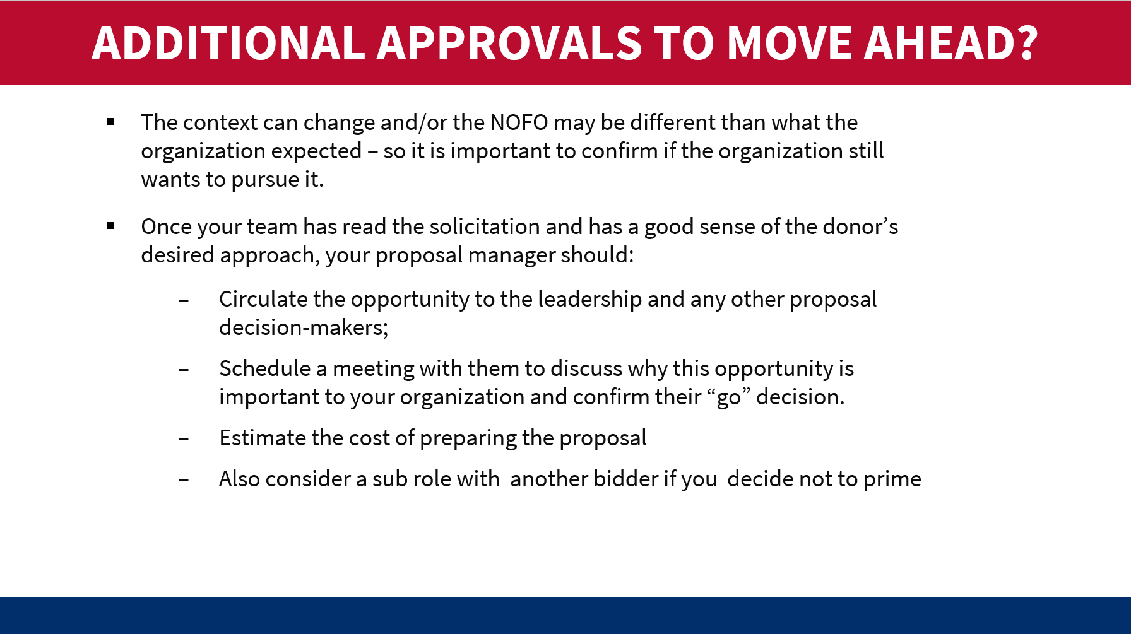

M 4.3: Proposal Kick-off Meeting
Relevant slides: M 4.3/#16-18
Purpose:
  - To appreciate the value-add of holding a Kick-Off Meeting as soon as possible once the solicitation goes live.
  - To understand the types of topics and decisions to be covered in this meeting as well as the immediate follow-up actions.
Content:
  - Purpose and key topics/agenda items for the Kick-Off Meeting.
Delivery mode/activities:
- One way to undertake this session would be to simply present Slides M 4.3/#16-18, as they are quite straightforward. In doing so, you can ask volunteers to discuss their experiences with Kick-Off Meetings (if anyone has done them before).
- But if the team has limited experience with this and if energy is low, another approach could be role play. You could divide the participants into groups, with everyone assigned a specific function on the proposal team (e.g., a proposal manager, a technical expert, an M&E expert, a finance/budgeting specialist, a program management staff) plus a few reviewers). Give them a handout with the agenda items (SEE BELOW) and select a NOFO from a country as an example, then ask the person playing the role of Proposal Manager to facilitate the meeting. In real life, it would take a couple of hours, but this could be done in a pretend for just 15 minutes or so. The aim is to get them familiar with the types of topics to be discussed in a way that is engaging and will reinforce retention of the content covered in this session.
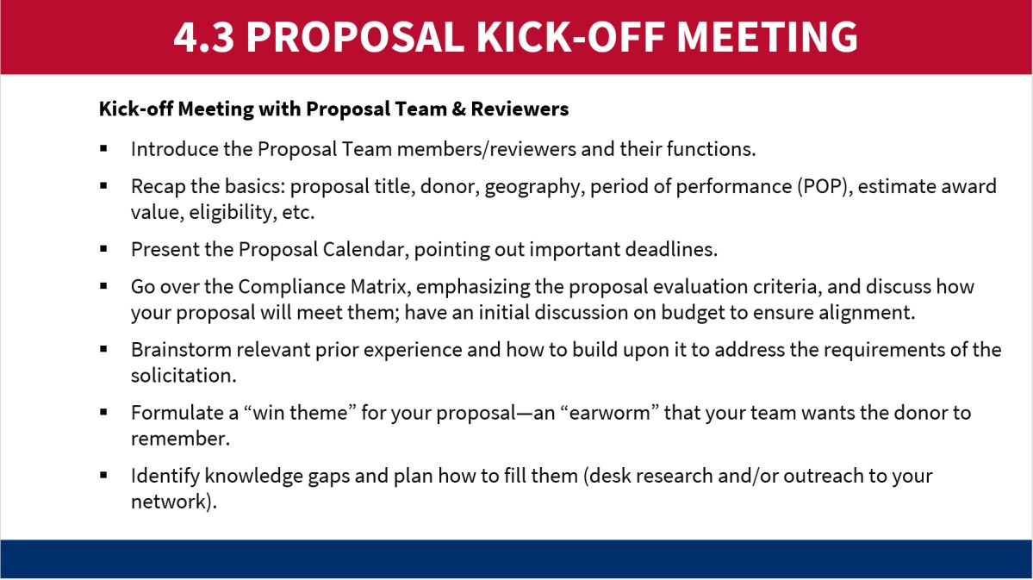

M 4.4: Preliminary Steps before Writing the Proposal
Relevant slides: M 4.4/#19-23

Purpose:
  - To highlight some important steps to be taken before diving into project design and proposal development.
  - To offer tips on going about asking the donor questions.
Content:
  - Fill in information gaps.
  - Execute teaming agreements (TAs) with finalized SOWs for partners.
  - Prepare questions for the donor.
  - Subscribe to the opportunity on SAM.gov and Grants.gov (as applicable).
Delivery mode/activities:
- State the following in plenary: We have read and re-read the solicitation documents, we’ve gotten ourselves organized, and we’ve conducted the kick-off meeting. Now what? Are we finally ready to write the proposal? Raise your hand if you say YES. Raise your hand if you say NO. (At this point, it is likely that many participants will enthusiastically say YES!)
- In response, tell them that there’s still a bit left to do before they can start writing. Yet point out that all the steps until this point should have taken place within a matter of hours or days after the NOFO was released – so even if the list of actions seems large, it is all happening quite fast. Even the “preliminary steps before writing the proposal” that will be presented now need to be completed as quickly as possible.
- Then briefly present Slides M 4.4/#19-23, going bullet by bullet.
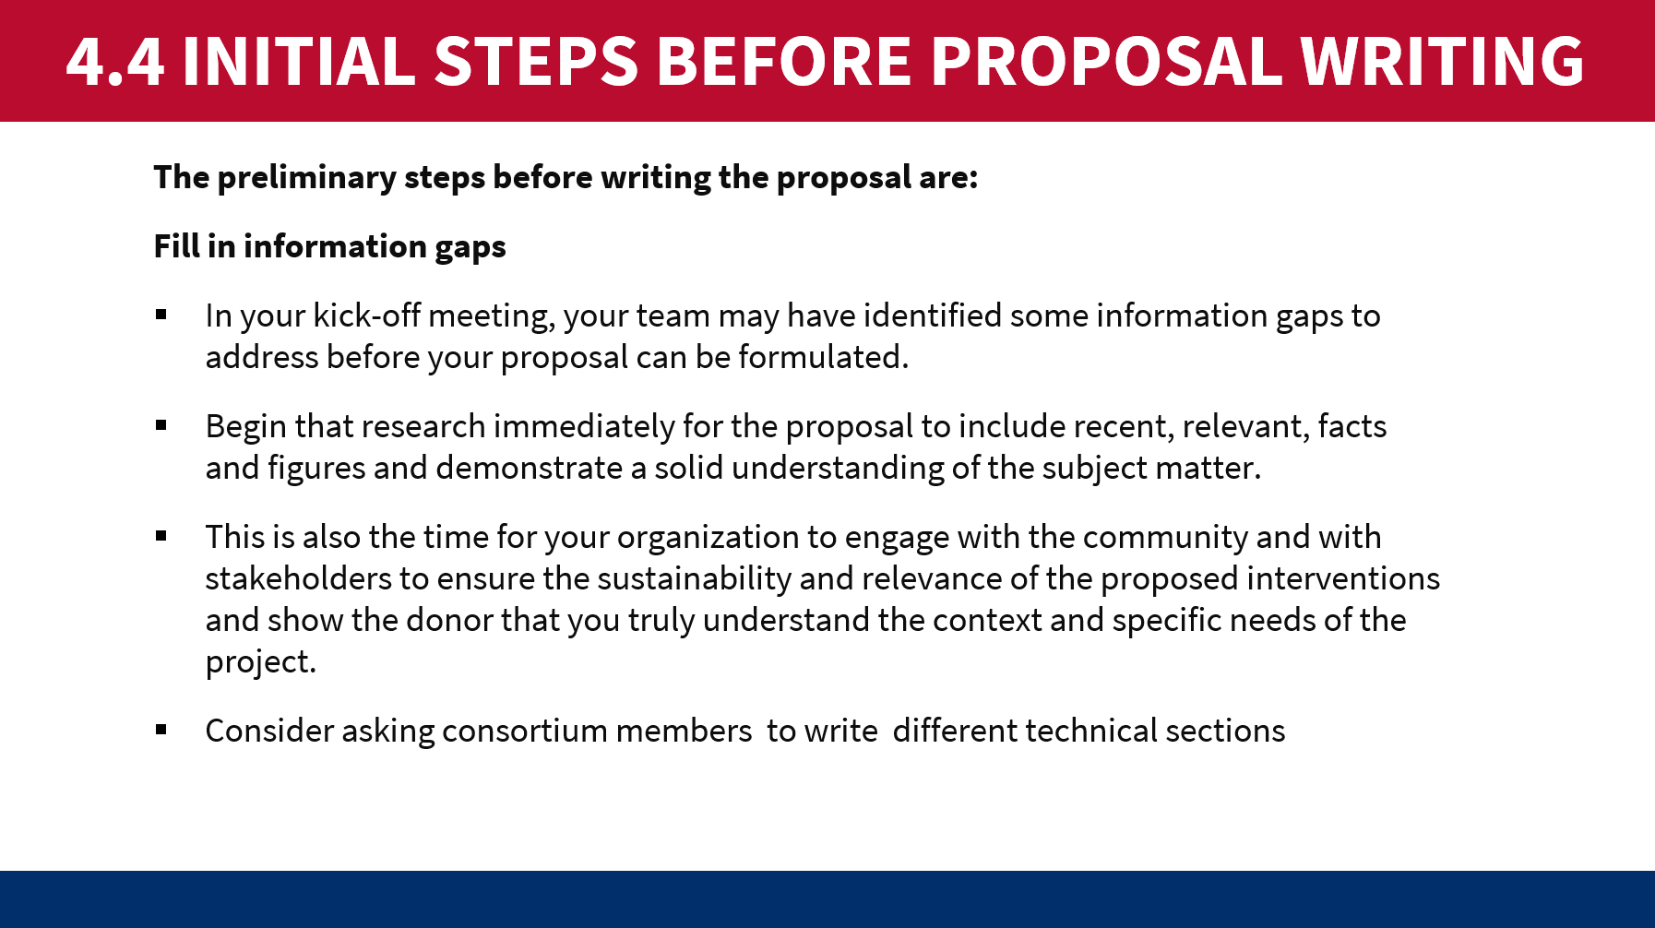
  - For Slide M 4.4/#20 (shown below), you may need to remind them what a Teaming Agreement is (referring to the Notes in the slide; it was discussed already, but a refresher can help).

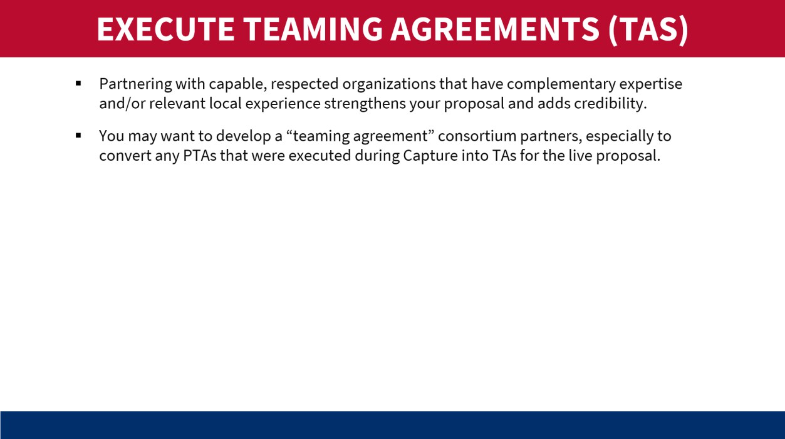
  - For Slide M 4.4/#23 (shown below), point out that (as noted in the Slide Notes) these websites are not used by all donors or even all USG Agencies; they are mostly for USAID’s calls for proposals/applications.
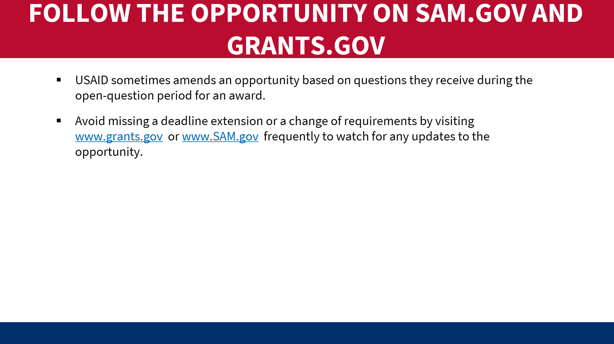

MODULE 5: PROJECT DESIGN AND PROPOSAL AND BUDGET DEVELOPMENT
Learning Objectives:
    - To design a theory of change and technical approach that includes consortium members and perhaps a grants program
    - To develop a management and staffing plan and MEL Plan
    - To develop organizational capacity
    - To develop a cost proposal

M 5.1: Project Design and Proposal Development
Relevant slides: M 5.1/#1-63
Purpose:
Technical Proposal
- To emphasize the importance of undertaking a participatory project design process prior to proposal writing and introduce or refresh participants to the aspects of the project design process.
- To familiarize participants with what a typical USAID technical proposal looks like.
- To provide information on what each key component of the technical proposal should consist of.
Cost Proposal
To develop a budget that covers all program costs including direct and indirect costs.
Content:
  - Importance of project design/conceptualization work before starting to write.
  - Key components of a proposal – particularly a typical USAID proposal.
  - Process for project design and drafting the written pieces.
  - Overview of major components:
- Project Design and Technical and Budget Proposal Development
  - Technical Proposal:
    - Technical approach
      - Project design
        - Theory of Change
        - Logic Model and Results Framework
        - Root Cause Analysis
        - Solutioning and Activity Descriptions
        - Evidence
    - Management and staffing plan
      - Organizational chart
    - Monitoring, Evaluation and Learning (MEL) Plan
    - Organizational Capacity and History of Performance
    - Cross-Cutting Issues
  - Cost Proposal:
    - Budget, with particular observations/tips on salaries & wages, indirect costs, and cost share
    - Budget Narrative
    - Supporting documentation
- Tips and Considerations for a Strong and Compliant Proposal Package
- Proposal Review and Editing
- Proposal Finalization and Submission
- Delivery mode/activities:
      - Technical Proposal
- Go through Slides M 5.1.1/#3-6 one by one to introduce this module. It’s important to emphasize that the Technical Approach is the most important section of any proposal and carries the most weight in USAID’s evaluation. Therefore, it is important for proposal teams to spend time on this together and make sure to get it right.
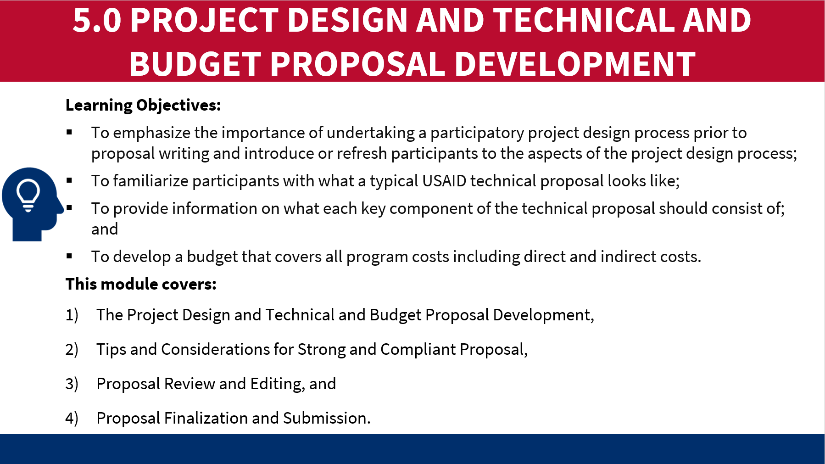

- Remind the participants that the entire proposal is based on the design of the Technical Approach and should be well thought out to inform other decisions such as the budget, management and staffing plan, and the MEL Plan.
- Emphasize that it’s extremely important to develop and fine-tune the Theory of Change, programmatic activities to meet expected outcomes before beginning to write the 20 – 25 pages.
- At the end of this slide, ask the participants if they have been involved in proposal writing and what did they learn from the experience. Some responses to listen for or prompt are assembling the proposal team and partners for discussions, and compiling background information needed to conduct these design discussions.

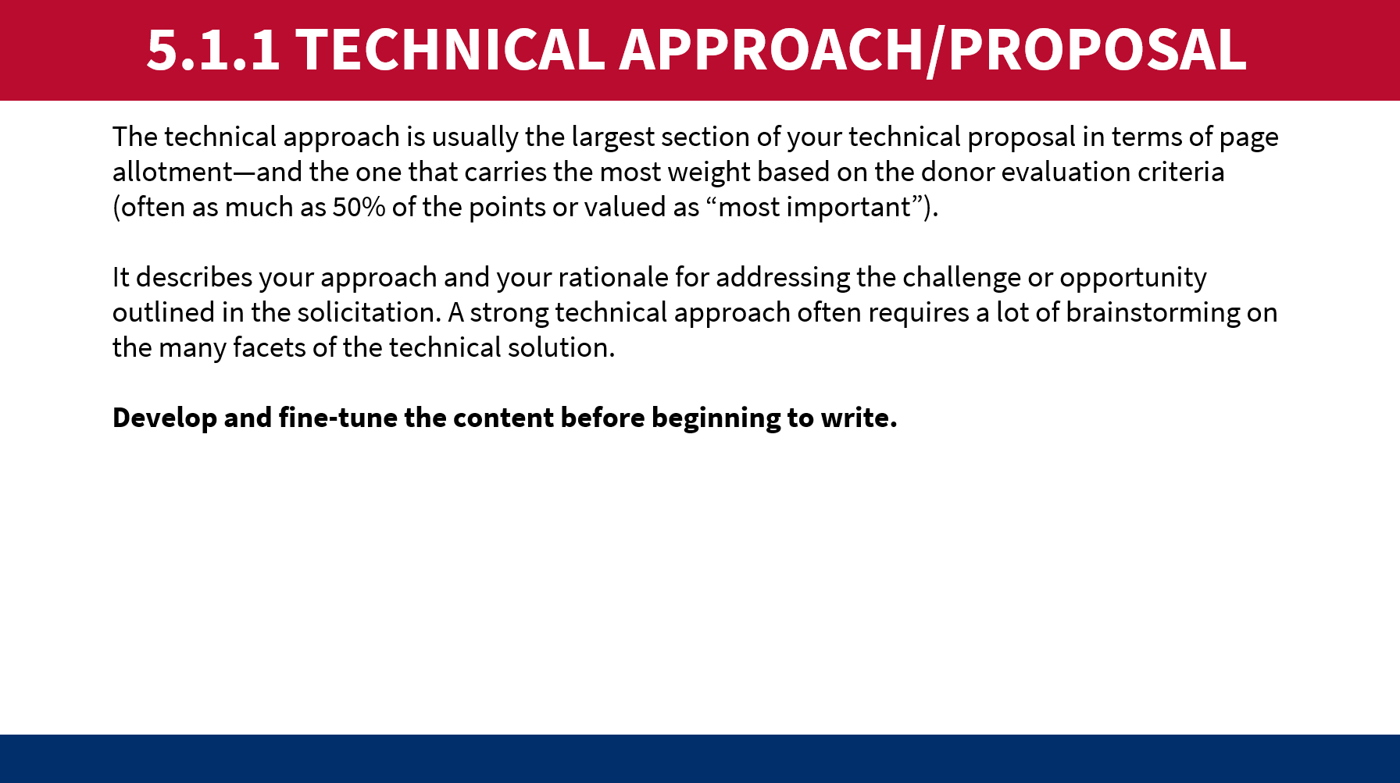
- Slide M 5.1.1/#7, provides an overview of what a TOC is, why it’s important, and the process to create it. Go through the 5 components of a TOC.
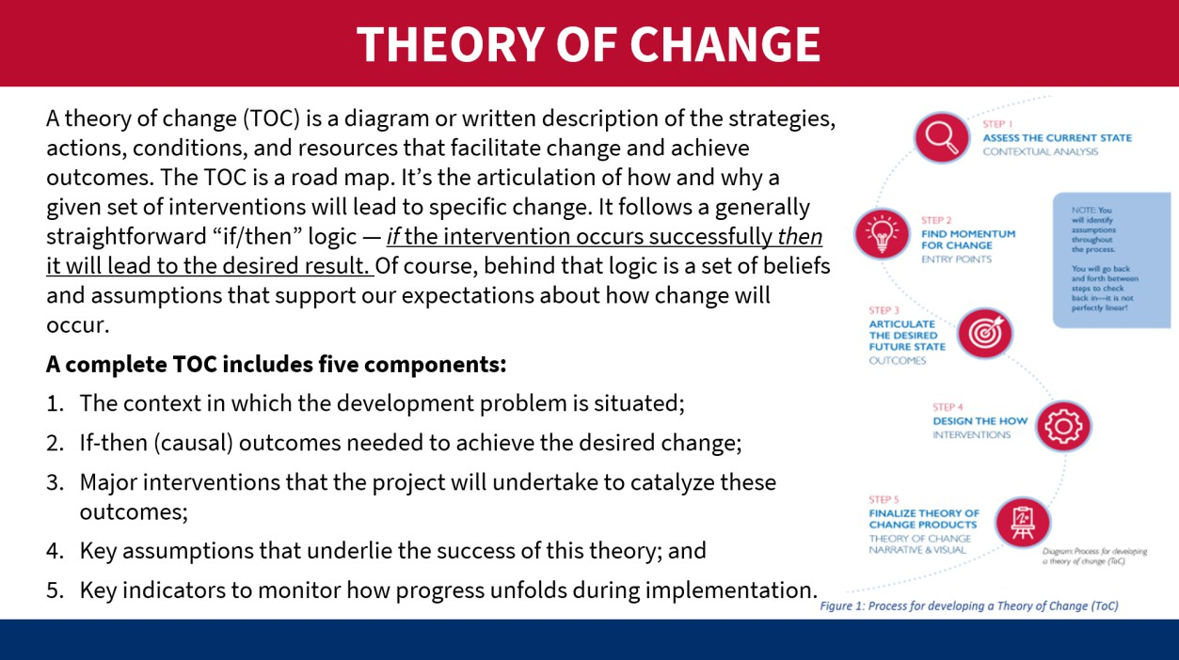
- Pause here for a plenary discussion – ask participants if they have created TOC before, allow them to ask questions, and share lessons learned from developing TOC before. This is also a good way to gauge any challenges LIPs have faced in developing them.
- Slides M 5.1.1/#8-9, walk the participants through the examples on and ask participants for any other examples or experiences they would like to share.
- On Slide M 5.1.1/#10, introduce the Logic Model explanation– provide an overview of what a logic model is and how it is used in the project design process, and relates to the TOC, using the graphic on the slide to show causation is demonstrated from the bottom up and uses if/then language like the TOC. Most participants should be familiar with this. Emphasize that a results framework is a type of logic model that USAID uses.

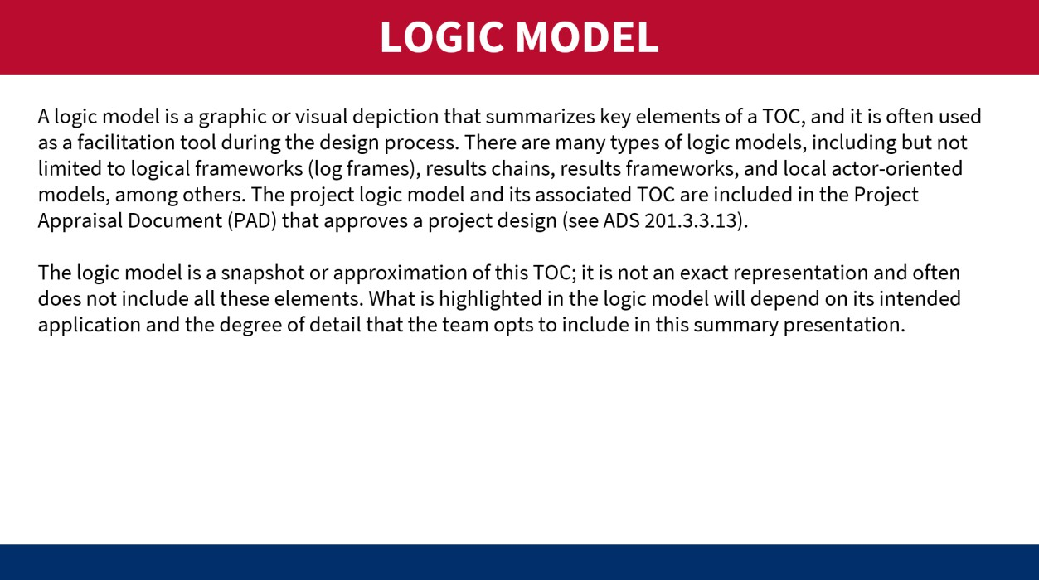
- Review the example logic models on Slides M 5.1.1/#11-12 and note this is how it should look when it is final, reviewing each column – working from the bottom up to demonstrate that the sub-purposes and assumptions, if met, will result in the overall Purpose at the top.
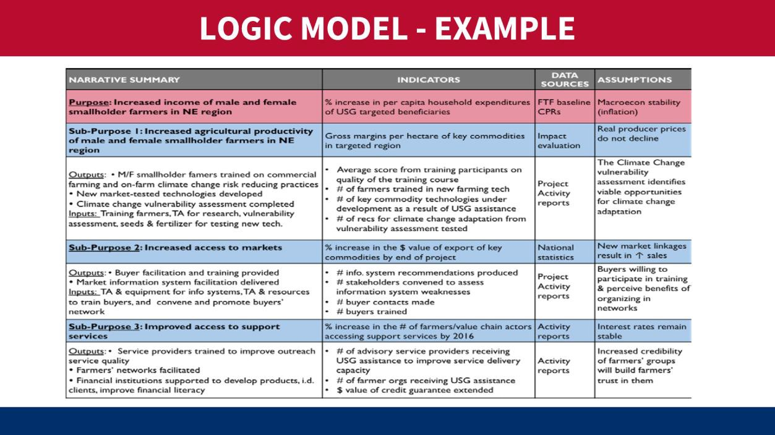
- Introduce the Results Framework (RF) and example on Slide M 5.1.1/#13. Highlight that USAID uses RFs in its Country Development Cooperation Strategy (CDCS) and its solicitations. Go through each Objective and its Intermediate Result (IR) to show that achieving these will reach the overall project Goal.

- The previous slides show the results of the project design activities but Slide M 5.1.1/#14 (below) shows how to get there. Emphasize that there are several steps you must take before getting to that final if/then statement or logic model.
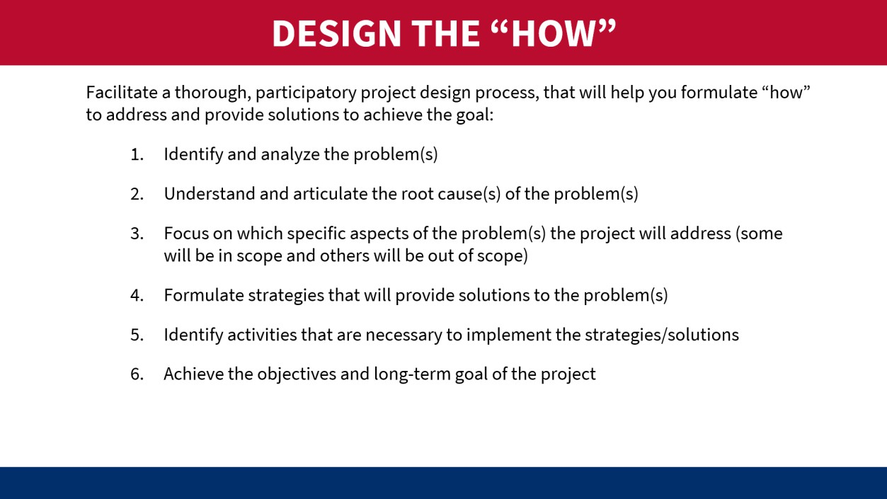
- On Slide M 5.1.1/#15, give an overview of what a root cause is and how to identify it to develop solutions. Identifying the root cause(s) of the problems is the foundation of creating a TOC. This is likely where proposal teams will spend a lot of time brainstorming and drilling down to root causes and may need an outside facilitator to support these activities.
- Highlight the different tools that teams can use to find root causes and discuss as a group ideas for how to facilitate these discussions, especially if they must have the discussion virtually (with internal staff and partners).
- Using Slide M 5.1.1/#16 (below), divide participants into groups of four people. Give each group a different problem and instruct them to use the 5 Whys tool to identify the root problem. After 10 minutes, ask each group to report the root cause for each original problem. Allow each group to use chart paper/sticky notes to complete the exercise. Problem prompts (these examples – feel free to make up your own): The internet at the office goes out often. An employee is late to the office every day. The patient didn’t attend their doctor’s appointment. The project team was late turning in the quarterly report.
- At the end of the activity and everyone has reported out, continue the slide, and click through the 5 Whys example – the vehicle won’t start – going step by step.
- Ask the groups for any feedback about the activity and if they have used other tools to conduct a Root Cause Analysis.

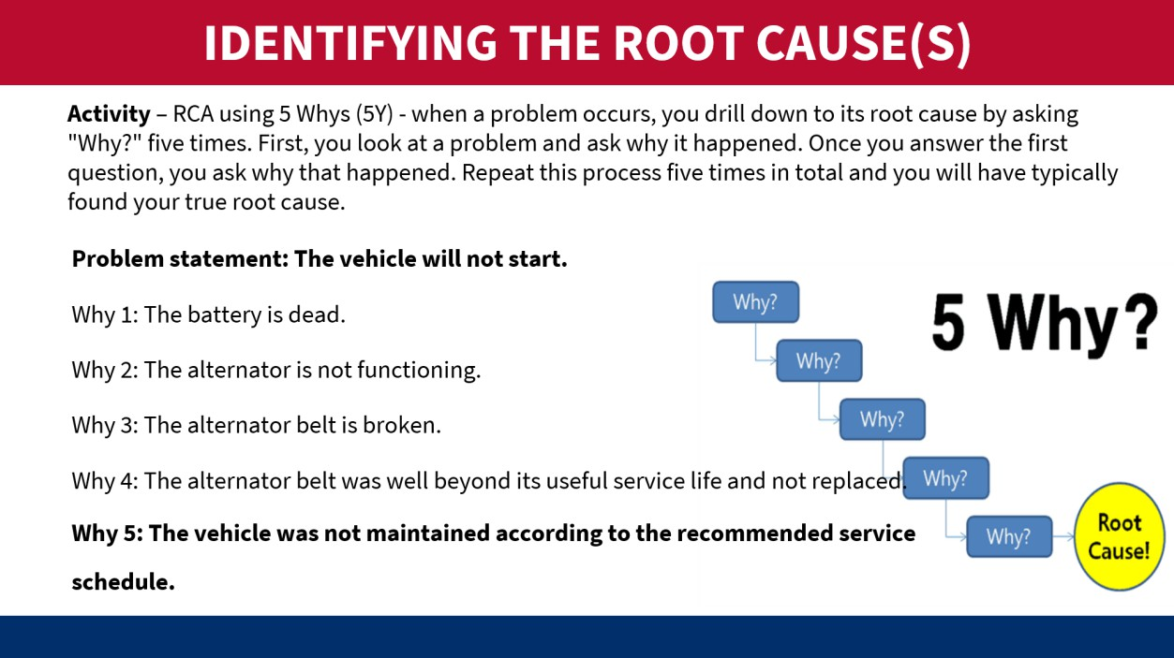
- Moving on to Slide M 5.1.1/#17, bring the groups back in the plenary and recap what the root cause of the example 5 Whys exercise was. Then, show the participants how to “flip” the root cause to the solution, and then the last bullet demonstrates turning the solution into a clear activity (the who, what, how, when).
- As you move to Slide M 5.1.1/#18, flag that this slide is a repeat of Slide M 5.1.1/#14, but with answers. Click through each bullet to show how the previous exercise about the vehicle matches these steps. Take a pause after each bullet to ask the participants if they have any questions or anything to add, this is particularly necessary for bullet 3 as it shows how something is out of scope, even if it feels relevant.
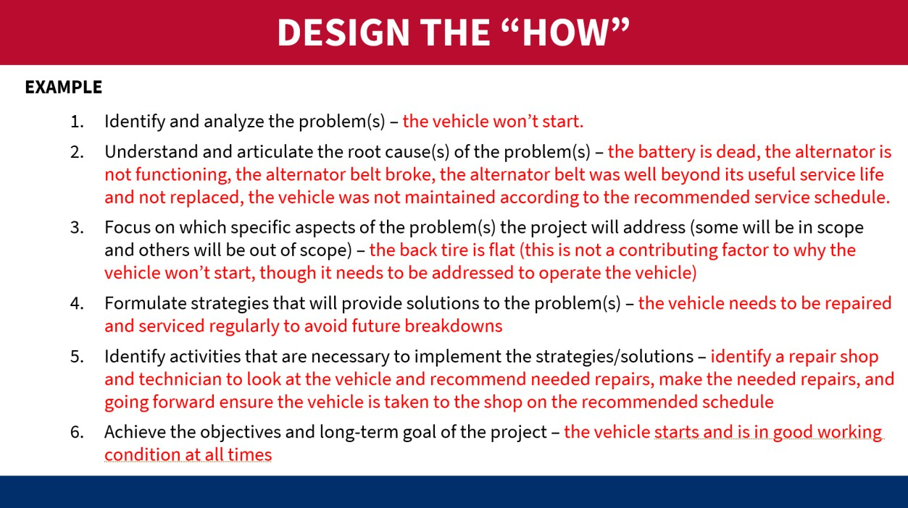
- The what, how, who, where, and when is detailed on Slide M 5.1.1/#19– emphasize on this slide that all this information is what needs to be answered for each activity you are planning as USAID will be looking for this in their evaluation of the proposal, and this information is essential to putting your management/staffing plan, MEL plan, and budget together. Without this information, you will have a

a lot of gaps in your proposal and USAID will have a lot of questions or will deem your proposal non- compliant.
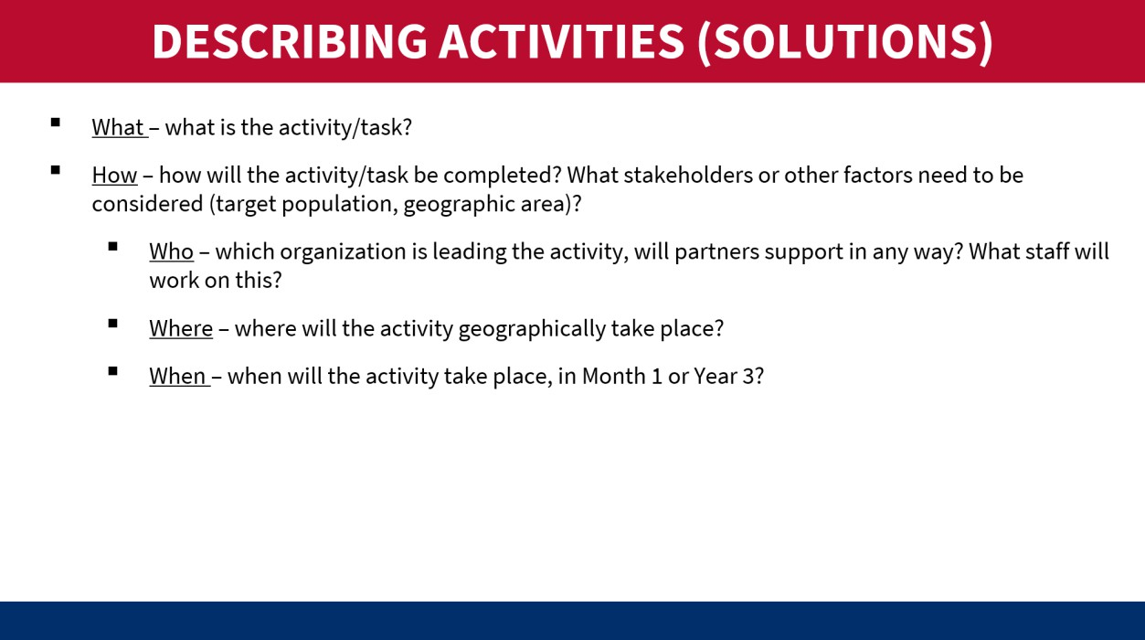
- Use Slide M 5.1.1/#20 to show the Ishikawa diagram, also called the Fishbone diagram, as a tool used to identify problems in a system. It shows how causes and effects are linked and helps analyze what is going wrong with systems, processes, and products. The name comes from Japanese engineer Kaoru Ishikawa who developed the method in the 1960s. a reminder to participants that USAID wants to see evidence-based solutions in the technical approaches.
- Go through Slides M 5.1.1/#21-24 to show the participants relevant polices for aligning their proposal activities with USAID and PEFAR policies.
- Use Slide M 5.1.1/#25 as a reminder to participants that USAID wants to see evidence-based solutions in the technical approaches.
- Slide M 5.1.1/#26 summarizes the different USAID sites that organizations can go to find data and information and remind participants that all USAID-funded project reports should be publicly available and work with your MEL staff to find those key sources during the proposal development process.
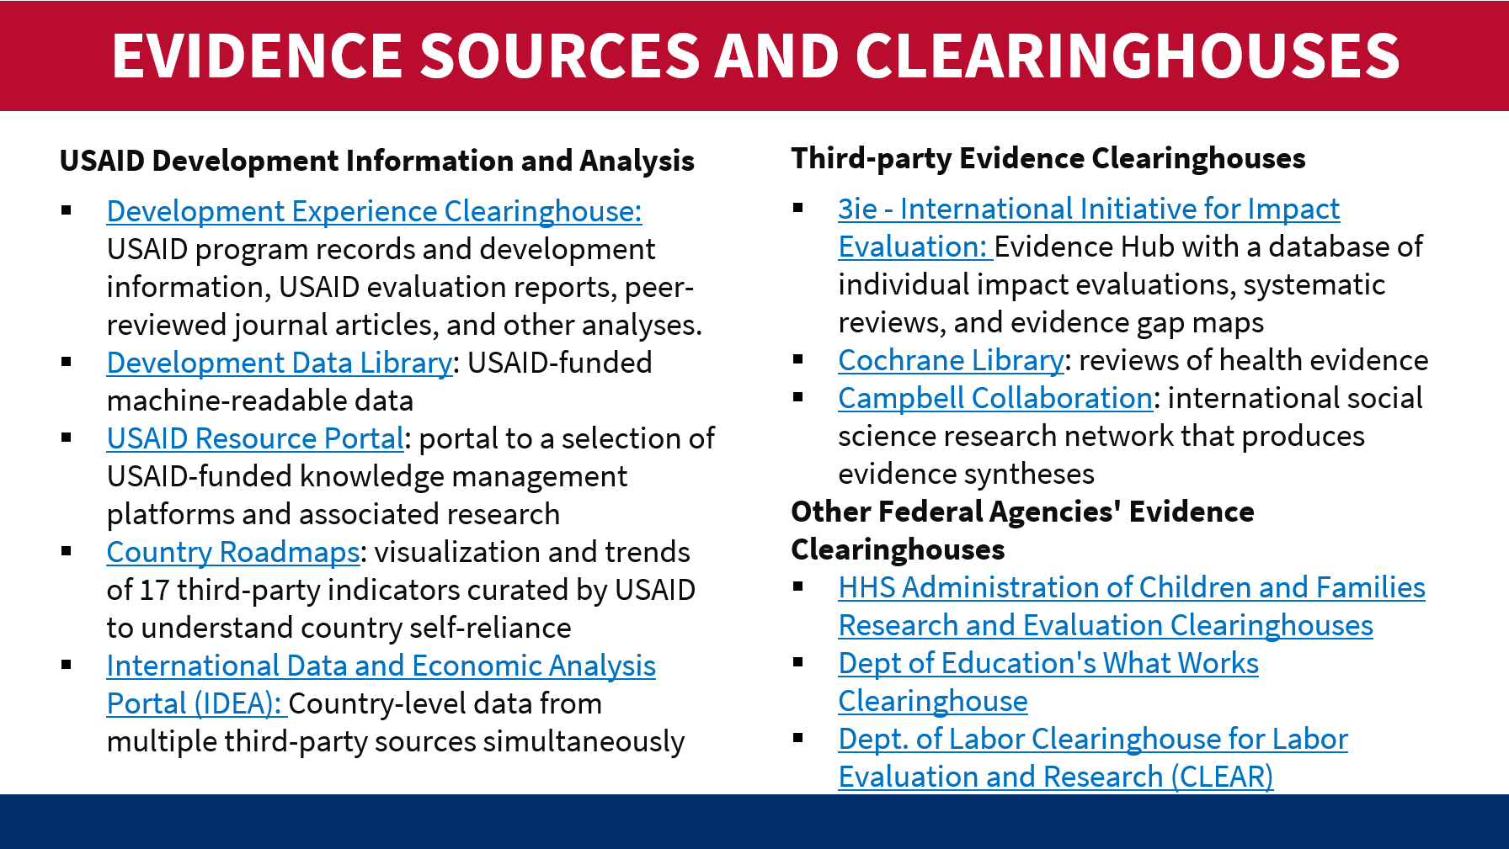

- Slide M 5.1.1/#27 provides links to all resources used in previous slides, many of which include examples, workbooks, etc. that the participants can use in future processes.
- You’ve just gone through a lot of information, pause on Slide M 5.1.1/#28 to allow the participants to ask questions, and share tips and lessons learned about project design (do’s, don’ts, feedback they’ve gotten from the donor, etc.). Once you’ve taken time to wrap up this part of the process, ask the participants if they are done. The answer is NO! They have only laid the foundation and now is the time to build the rest of the technical proposal pieces.
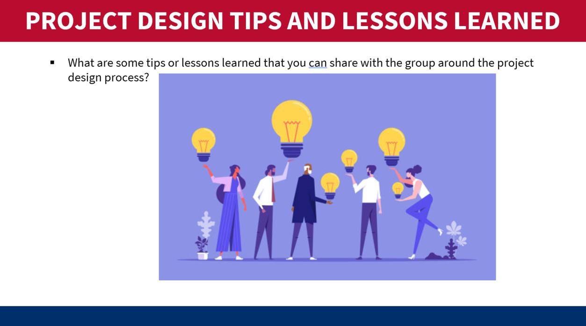
- Moving on to the management and staffing plan, this is usually the 2nd most important section of the proposal in terms of evaluation points. Take the participants through Slide M 5.1.1/#29 to provide them with an overview of what is usually included in the management and staffing plan required by USAID. And reiterate that the contents of this section are based on the technical approach/activities. This is the section that shows USAID how you’re going to operationalize the activities in your technical approach.
- The organizational chart is also a very important element of this section, as it is a visual representation of your staff, reporting lines, and how you’ll work with partners. Slide M 5.1.1/#30 includes best practices in putting together an org chart, including putting it together early and cost out the positions to ensure it fits the budget ceiling provided by USAID.

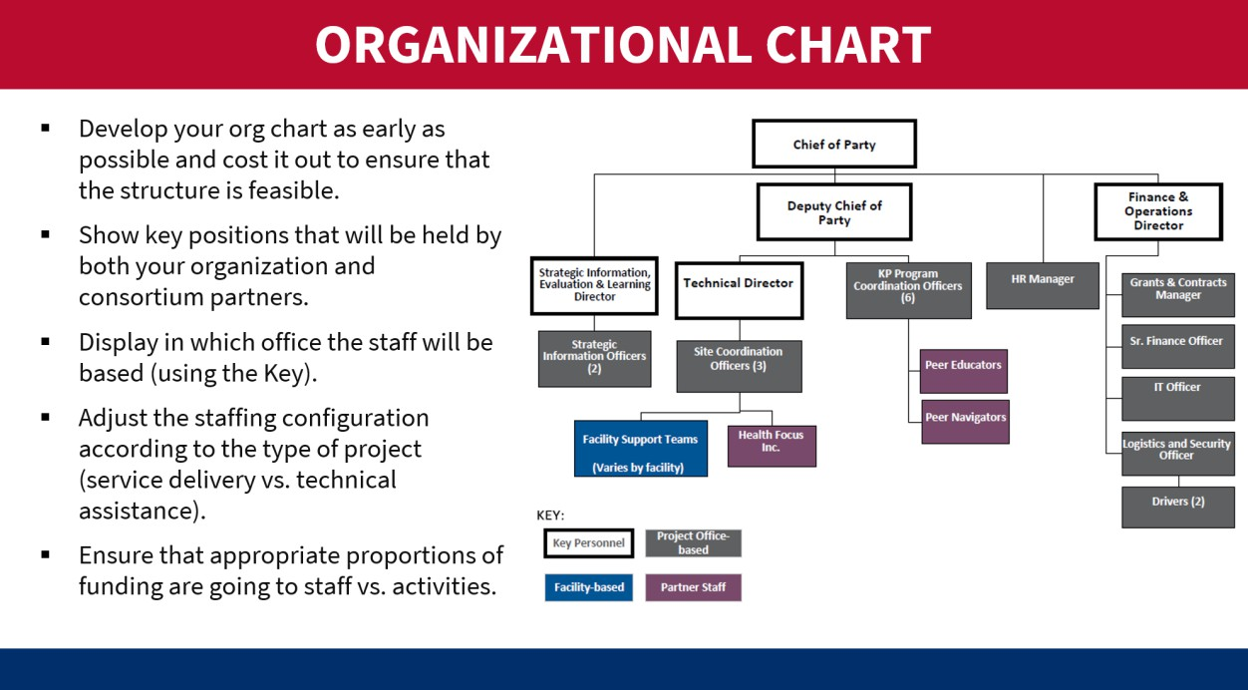
- A potential activity for this section could be to break participants into pairs or groups and given the good and bad examples of org charts, have them discuss and report what makes a good or bad org chart and what to watch out for when creating them. For tips on how to develop an organizational chart, see Slide M 5.1.1/#31 or visit here.
- Monitoring, Evaluation and Learning (MEL) Plan is usually evaluated as part of the Technical Approach and should be based on your TOC/logical framework. Slide M 5.1.1/#32 provides an overview of the draft MEL Plan and its requirements. The MEL Plan will track your progress toward the achievement of outputs and outcomes that will go on to achieve the goal of the project. This is an important tool for successful project implementation.
- Show Slides M 5.1.1/#33-34 and note that these are examples of PEPFAR MER reporting requirements and display a sample indicator frequency table.
- Organizational Capacity and History of Performance is usually the 3rd most important section in proposals. Slide M 5.1.1/#35 provides guidance on what is usually required for these sections. This is where your organization can demonstrate clearly to USAID that you have implemented this type of work before and that you have achieved results.
- Organizational capacity is where you can highlight results and give concrete examples of how you’ve been successful in the past in implementing projects that are of similar size and scope.
- History of performance is another piece that USAID may ask for and it requires the organization to fill out a template (screenshot in the slide). Highlight that in Box 9 USAID is asking for a person’s name/contact information who is familiar with your work. USAID will contact that individual directly to ask about your performance on that project, so choose carefully!
- Finally, Slides M 5.1.1/#36-40 describe some areas that are typically referenced as cross-cutting issues that the proposal should address, as these topics should be considered and factored into your activities/interventions. Gender is usually a cross-cutting issue in most USAID programming as we know gender norms/traditions can impact activities. Youth is another example of a population that needs to be considered and addressed within the proposal. Ask the participants what other areas they have seen to be cross-cutting.
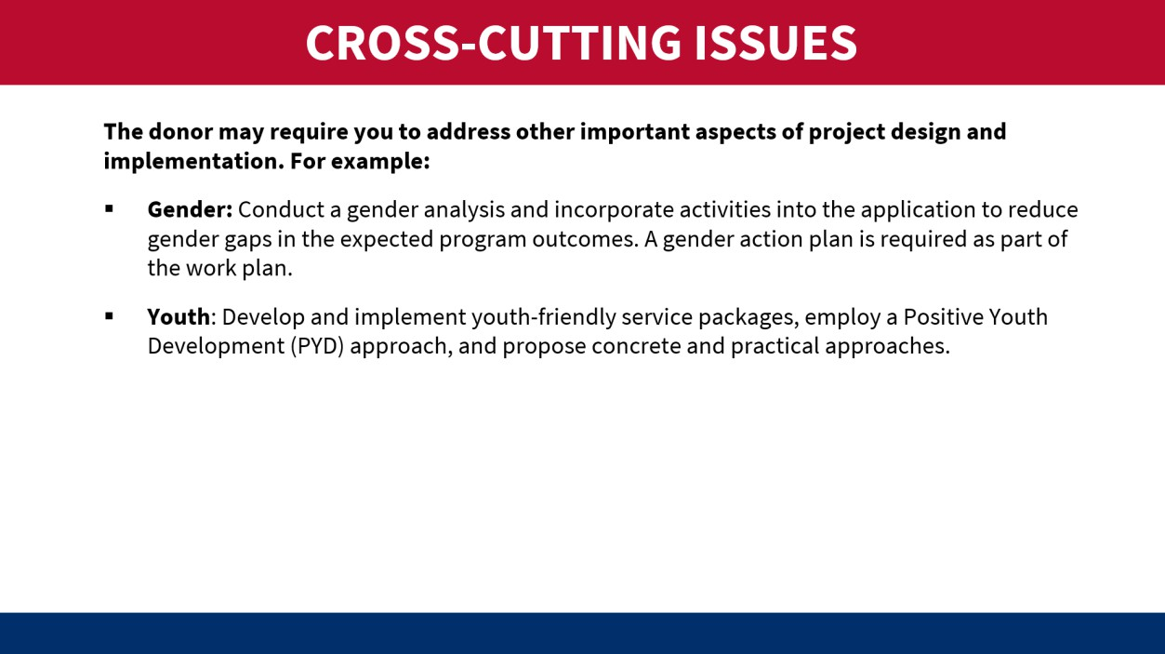
      - Cost Proposal
Slide M 5.1.2/#41: The Cost Proposal is reviewed separately from the Technical Proposal and has two components:1) Budget and 2) Budget Notes which is a narrative explanation of the budget figures.
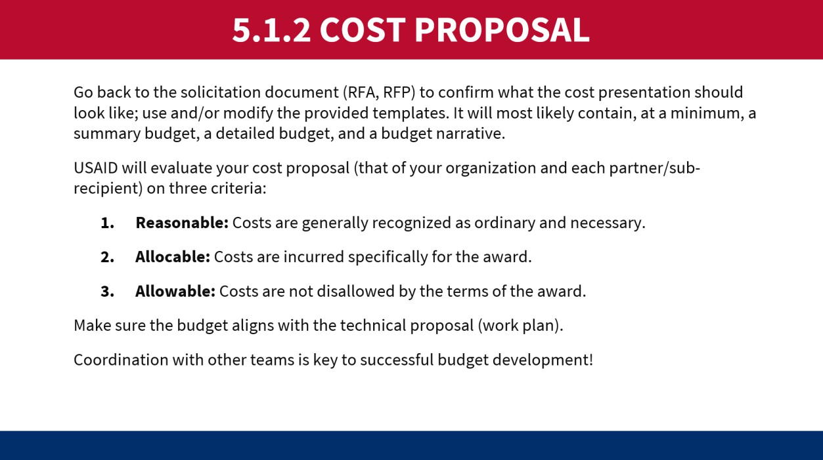
Slides M 5.1.2/#42-43: The budget covers the Life of the Project and the template you use must include all the details required in the proposal. Link to the budget template: https://www.usaid.gov/document/attachment-3-budget-template
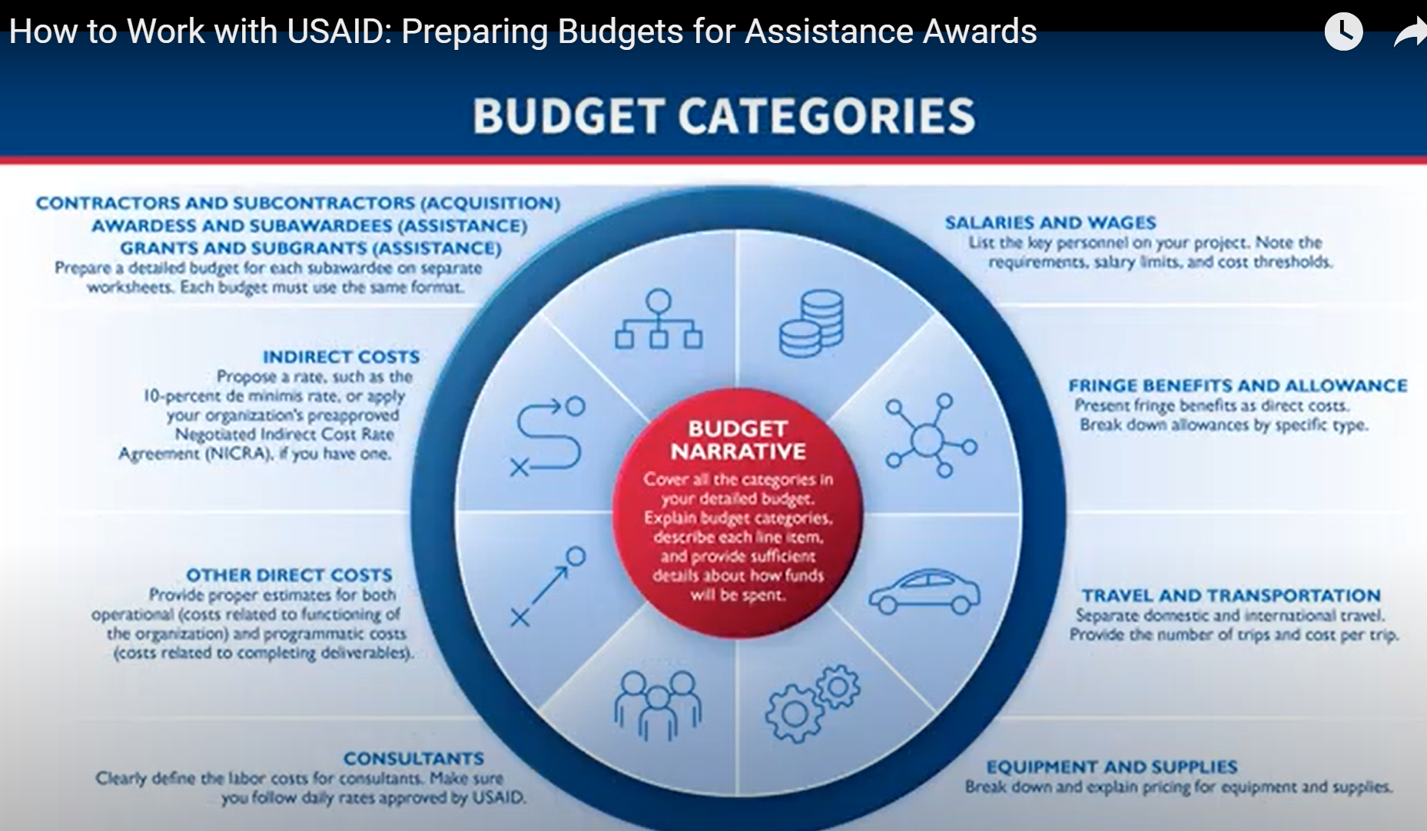
Slides M 5.1.2/#44-46: These slides are very important for participants to understand that the budget preparation phase is the only to ensure you include salary levels that will attract and retain staff. As t is important to understand the local salary market and use the budget available in the proposal to hire the skillset and experience you need. As a reference, please refer to local market salary surveys.
Slides M 5.1.2/#47-57: Indirect costs are those costs incurred for a common purpose that are too time-consuming/costly to allocate to a specific cost objective. Examples of indirect costs include office space rental, utilities, and clerical and managerial staff salaries. To the extent that indirect costs are reasonable, allowable, and allocable, they are a legitimate cost of doing business payable under a U.S. Government assistance award. For Fixed Amount Awards (FAAs), there is not a line item for indirect costs, but you can factor it into the total costs.
There are two types of indirect costs: 1) 10% De Minimis; and 2) Negotiated Indirect Cost Rate Agreement (NICRA). Alternatively, a project can include all costs for implementing the award as direct costs.
As of September 2023, 2 CFR 200.414(f) states that organizations can charge a 10% de minimis rate of modified total direct costs. It is anticipated that USAID will use the 10% de minimis as of October 2024. The de minimis should be calculated appropriately for each fiscal year.
The Modified total direct costs include all direct salaries and wages, applicable fringe benefits, materials and supplies, services, travel, and up to the first $25,000 of each subaward (regardless of the period of performance of the subaward). The 10% de minimis rate for modified total direct costs can only be elected under an award by a non-profit organization that has never held an indirect cost rate agreement.
The organization must include the 10% de minimis amount in its application and maintain documentation of costs included in its modified total direct costs. It must be used consistently across all USG awards. It is allowable for use indefinitely.
Administrative and clerical salaries should normally be treated as indirect costs (finance and administrative costs). In contrast, administrative and clerical salaries that can be identified specifically with a final cost objective, (i.e. award), should be charged as a direct cost.
Here is a proposed exercise for Slide M 5.1.2/#58 on Indirect Costs:
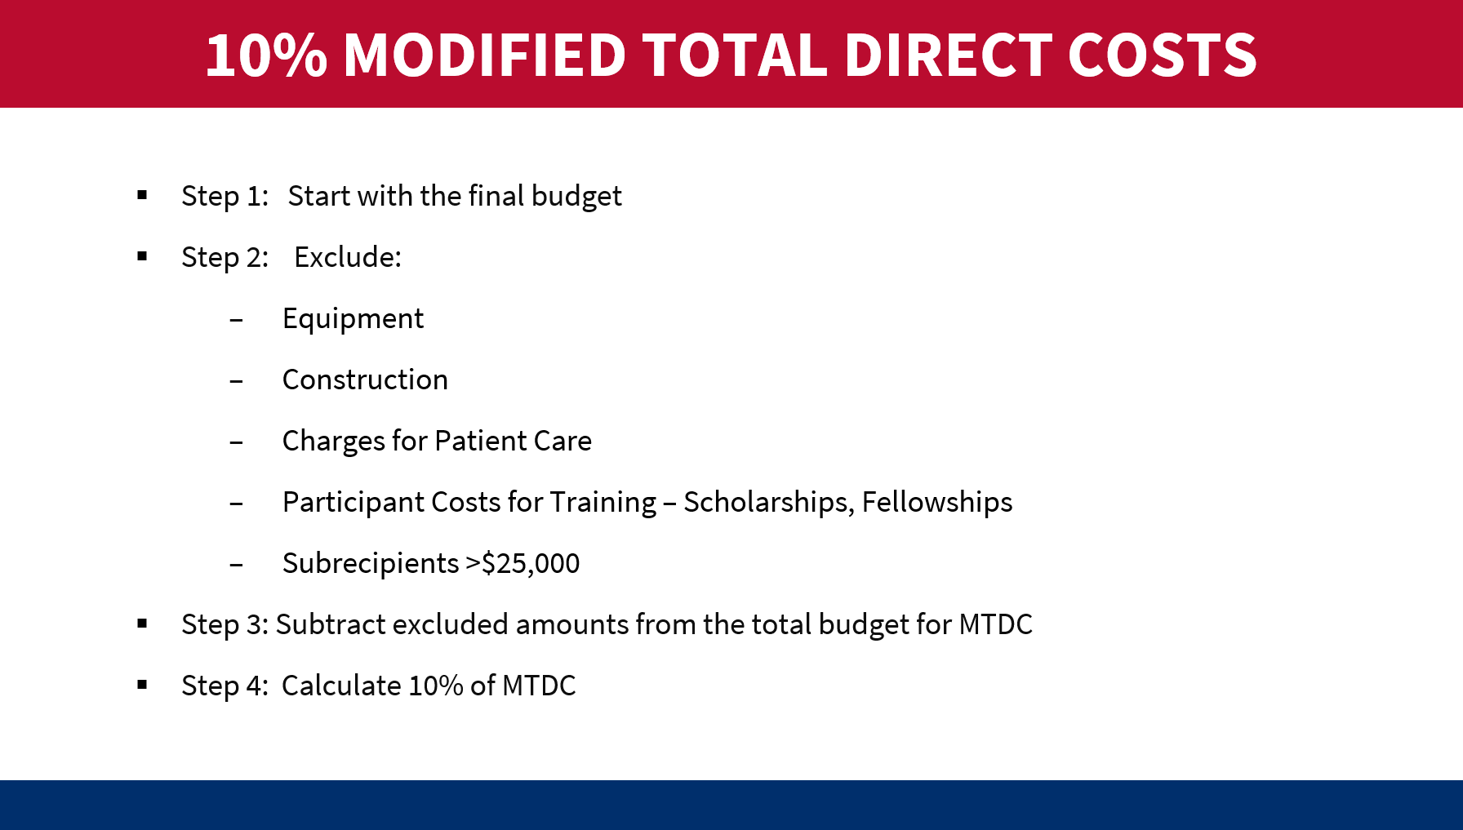
Slide M 5.1.2/#59: A NICRA is a document published to reflect an estimate of indirect cost rate negotiated between the USG government and a Grantee/Contractor’s organization which reflects indirect costs (facilities and administrative costs) and fringe benefits expenses incurred by the organization.
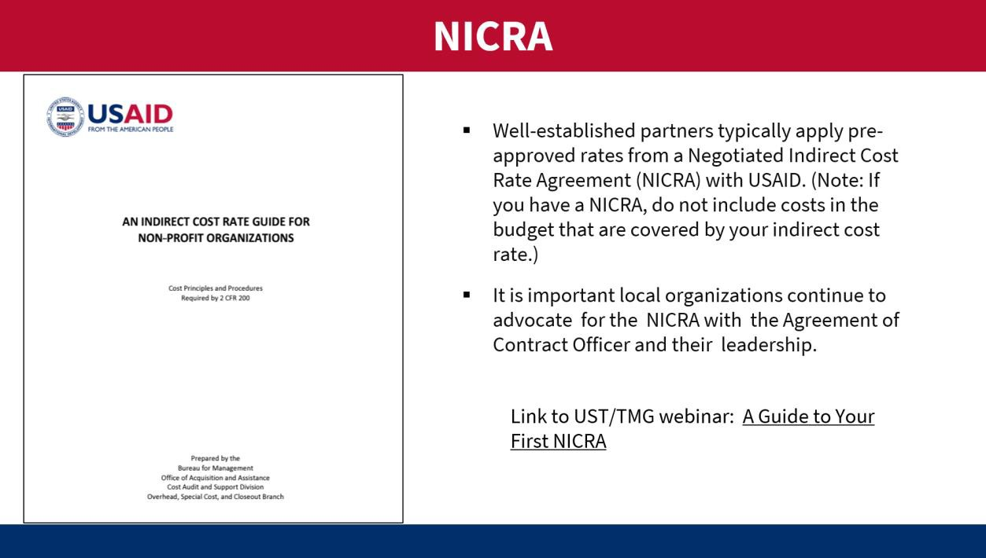
The key to applying for a NICRA is to invest in accounting systems so you can demonstrate your direct and indirect costs. The NICRA is covered in an annual audit. There are other resources available for this topic: https://www.youtube.com/watch?v=g_DnQxiGErU and https://www.usaid.gov/partner-with-us/get-grant-or-contract/trainings-how-work-usaid.
USAID predominantly uses the provisional and final indirect cost rate methodology when negotiating rate agreements. 2 CFR 200, Subpart F, Appendix 4, Section C.2.f. states that provisional and final rates must be negotiated where neither predetermined nor fixed rates are appropriate. Predetermined or fixed rates may replace provisional rates at any time prior to the close of the organization's fiscal year. If that event does not occur, a final rate will be established, and upward or downward adjustments will be made based on the actual allowable costs incurred for the period involved.
Slides M 5.1.2/#60-61: Many proposals require Cost Share or “matching” resources provided to the activity and included in the budget. This is an appealing element to USAID and needs to be well-planned. Only non-USG funds or in-kind items not donated by USG count towards cost share. Many organizations over-promise on cost share or do not create the required accounting systems to capture this information.
Slides M 5.1.2/#62-63: The Budget Narrative must mirror the outline of the budget spreadsheet and provide sufficient descriptions and justifications for each line item. Remind participants that the budget is reviewed separately from the technical proposal and the reviewers will need sufficient background information to justify the cost.

M 5.2: Tips and Considerations for Strong and Compliant Proposal Package
Relevant slides: M 5.2/#64-67
Purpose:
- To share some tips and success factors for a strong proposal.
Content:
- Preparing for final reviews.
- Writing/editing tips.
- Compliance tips.
- Success factors (for a winning proposal).
Delivery mode/activities:
Slides M 5.2/#64-67: Present the main points about preparing a strong and compliant proposal package and undertaking the final review.
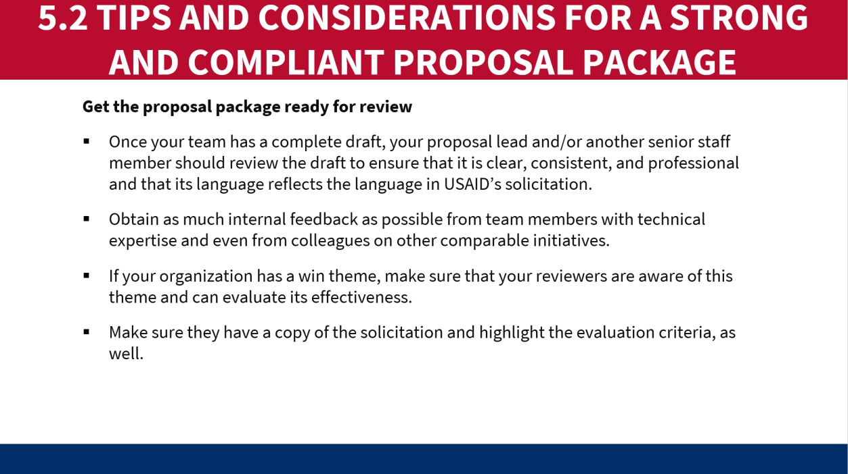

Slide M 5.2/#66: Review this slide (below) together. Some writers will cut past phrases from the NOFO into the outline to mirror elements and ensure they have covered the scope.
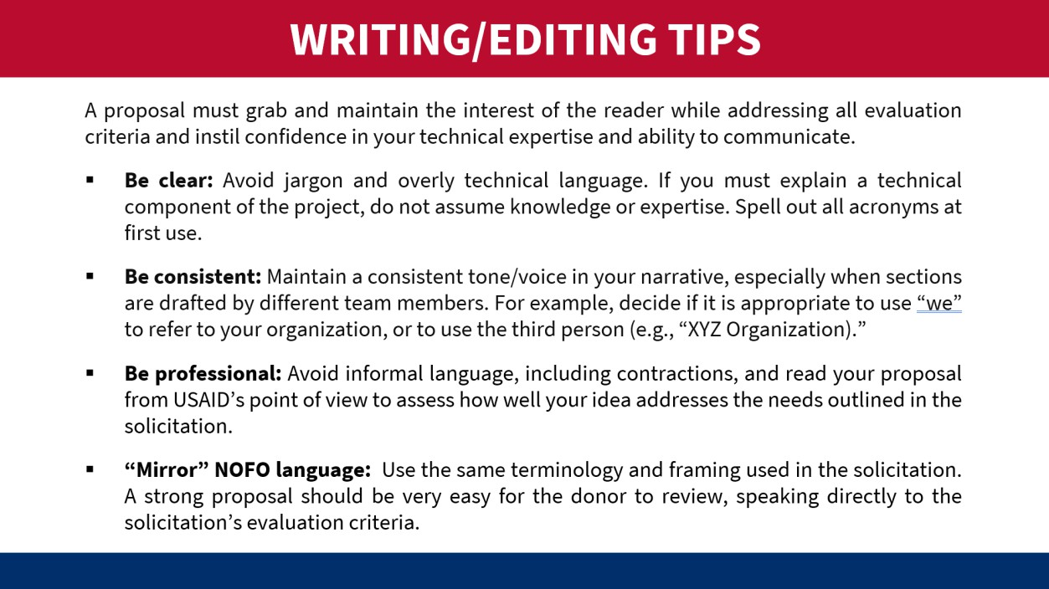
Slide M 5.2/#67: It is very important to create a checklist of what is required and have two reviewers ensure all elements are included. If you do not meet the compliance criteria you will be eliminated from the selection process.
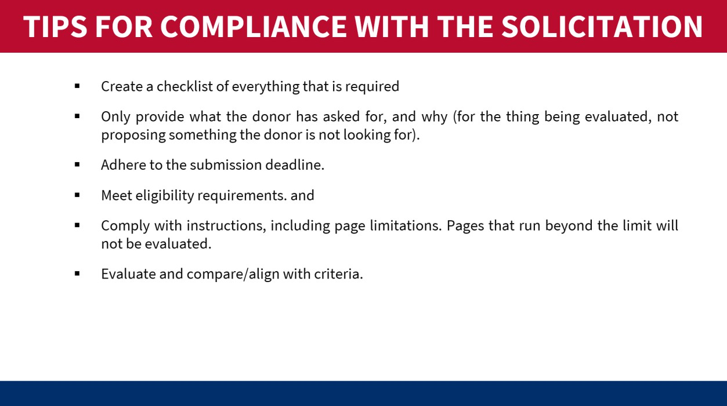
If the participants do have some experience with USG proposals, this is also a good time to ask a few of them to share the feedback they got on their proposals (if they feel comfortable). Both winning and losing proposals/feedback can be helpful for teams to understand what the donor expects, what the top standards are, and how they need to improve to be competitive.

M 5.3: Proposal Review and Editing
Relevant slides: M 5.3/#68-72
Purpose:
- To emphasize the importance of effective time management, allocating adequate time for review and editing of the proposal package.
- To provide an overview of the different types and stages of reviews that should take place.
Content:
- Purpose of proposal review; different types of reviews.
- Proposal review process.
- Time management.
Delivery mode/activities:
- Divide the participants into groups.
- Assign half of them the task of identifying the different points in the proposal development process when an internal review (by independent reviewers, not on the proposal team) should take place.
- Assign the other half the task of identifying the different components/aspects of the proposal that should be reviewed (by independent specialized reviewers, not on the proposal team).
- Have the groups debrief in plenary. Some groups will be tackling the same question, so ask each subsequent one to ONLY add ideas that weren’t already mentioned by groups that presented before them.
- Then present Slides M 5.3/#68-69 to check/validate their ideas and recap what is recommended.
- Stress that periodic reviews of the technical and cost applications are critical.
- If possible, engage staff not working on the proposal to review and provide feedback on technical and budget content, as well as compliance with USAID requirements.
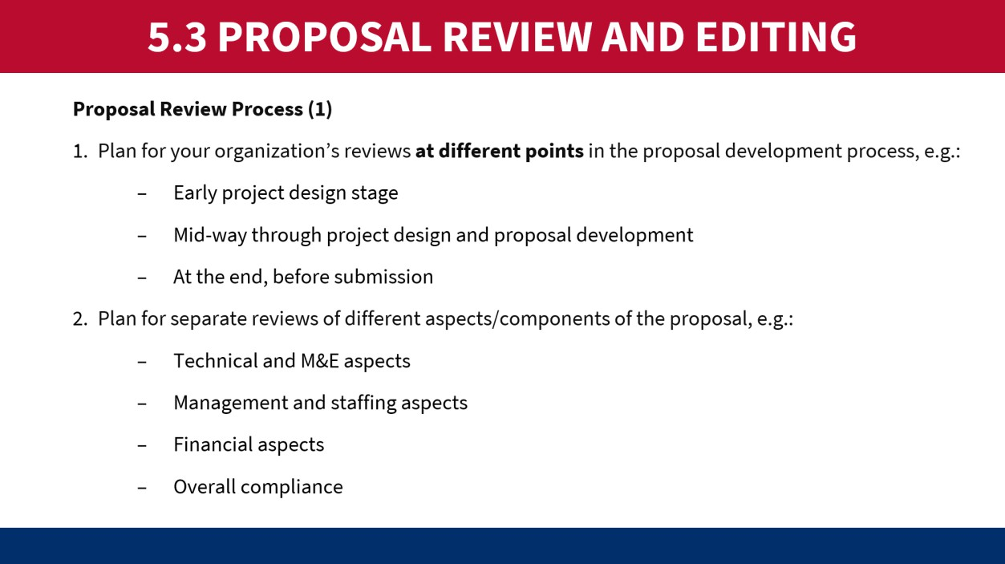

- Discuss the aims of these different types of reviews, using Slide M 5.3/#70 (below) as a guide.
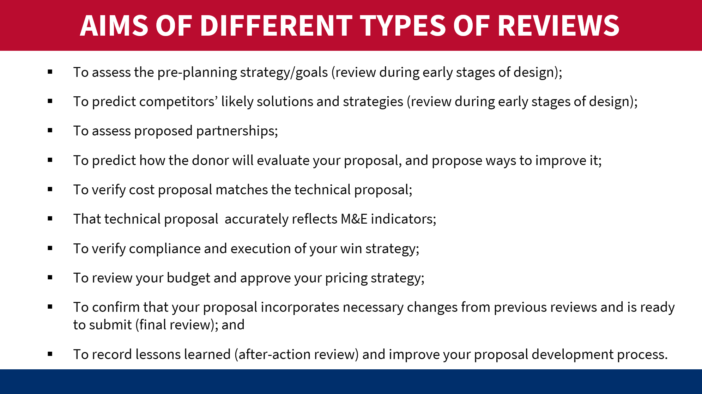
- Slide M 5.3/#71, take into account the review questions while reviewing the proposal.
- Wrap up the session by first asking the group how much time they think the review and editing process (to incorporate feedback from reviewers) typically takes. Project Slide M 5.3/#72 (below), pointing out that, ideally, at least 2 weeks should be allocated for review and editing! Then read the other bullets, all of which emphasize that time management and adequate planning are absolutely critical.
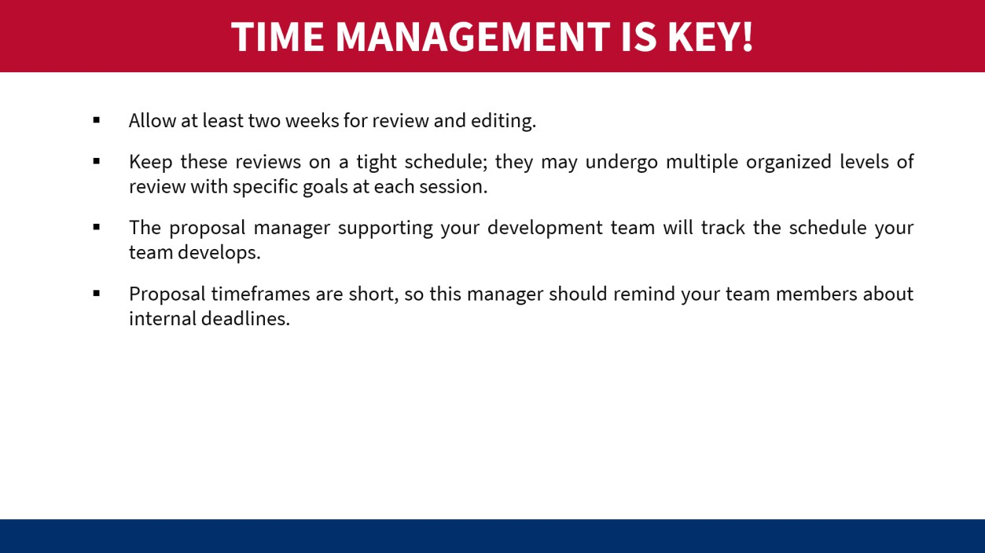

M 5.4: Proposal Finalization and Submission
Relevant slides: M 5.4/#73-74
Purpose:
  - To reinforce how critical it is to allocate adequate time for finalizing, packaging, and submission of the proposal.
Content:
  - Proposal finalization and packaging
  - Proposal submission
Delivery mode/activities:
- Present Slide M 5.4/#73, pointing out that the finalization and packaging of the proposal often takes
longer than people expect, so it’s important to allocate adequate time for these important tasks.
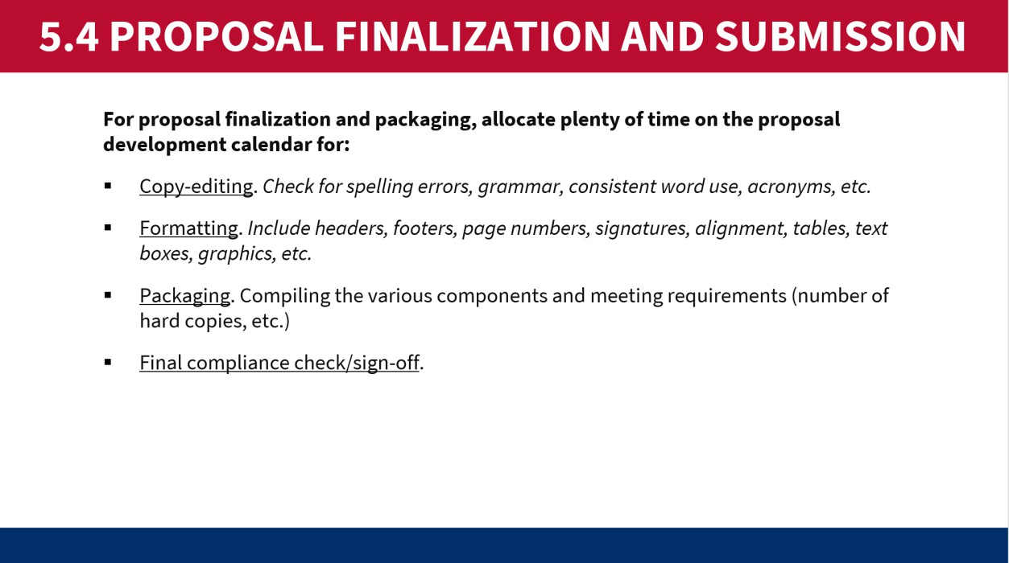
- Elaborate as follows:
  - Ensure that you build in time during your proposal development schedule for an editor to review your narrative for grammar, punctuation, American English spelling, formatting, clarity, and flow. The editor should reference the formatting requirements in the solicitation and the guidance in the USAID style guide to ensure a compliant, high- quality document.
  - When packaging the proposal, be sure to label all attachments as Annex 1 of 4, Annex 2 of 4, and so forth.
  - Submitting an error-free proposal shows the donor that you are detail-oriented and attentive to the quality of your work. It is also important for your editor to help your team adhere to any page limitations stated in the solicitation, as the donor will not review any
pages beyond the stated limit.
- Wrap this session up with Slide M 5.4/#74 (below), which offers tips on proposal submission.
  - In doing so, you can share practical examples of when these things – which may seem so simple – have gone wrong and all the efforts made to develop the proposal went wasted. For instance, the horror stories of the internet going down right when the team was trying to send out the proposal and them missing the deadline, or the proposal being sent to the wrong address and the team not realizing it until it’s too late; or the package file size is too big and either refusing to send or bouncing back. These real examples offer insight into the reasons why it is so important to build in buffer time and aim to submit the proposal before it is due – rather than waiting until the last minute.
  - Also, point out the importance of noting what time it’s due in WHICH TIME ZONE.

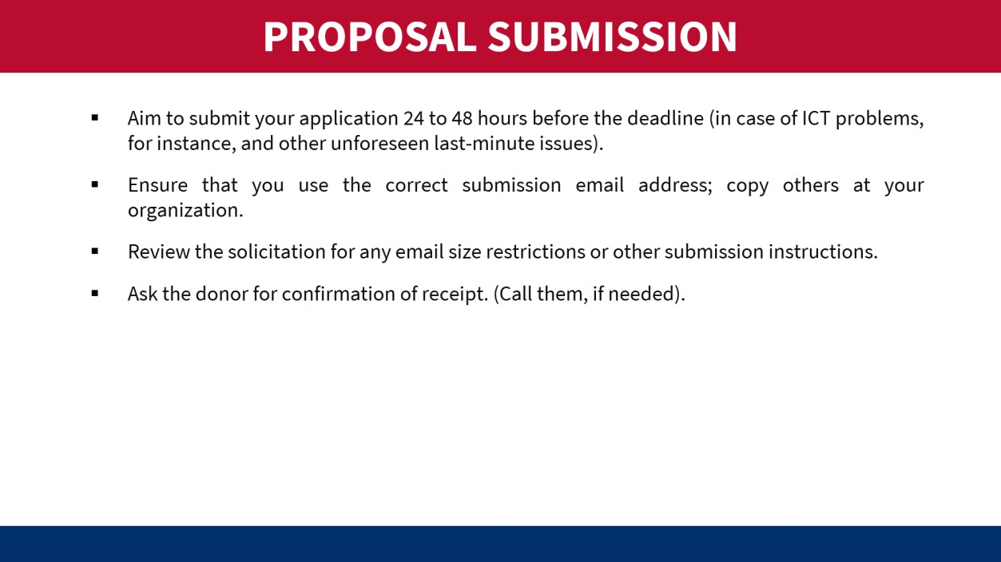
  - It’s important to emphasize that an on-time but imperfect proposal can win, but a late perfect proposal will never win. USAID is extremely strict about its submission deadlines, and it will not consider or read any proposal that is received after the stated deadline.
* This can be a good moment for a break, if needed/appropriate. *

MODULE 6: POST-SUBMISSION PHASE
Learning Objectives:
    - Appreciate the benefits of conducting formal post-action reviews to learn from the proposal development experience.
    - Be aware that it might be necessary to revise the proposal, should the donor come back with clarification questions or requests for slight changes, and
    - Acknowledge the importance of seeking and applying feedback on losses, so that future proposals will be even better.

M 6.1: Post-Submission Actions
Relevant slides: M 6.1/#2-4
Purpose:
  - To emphasize that the proposal work isn’t necessarily done once the package is submitted; there might
be a need to revise it or answer donor questions.
  - To encourage teams to conduct after-action reviews and analyze any feedback obtained from partners and donors, and
  - To point out that learning systems are beneficial for improving future proposals.
Content:
  - Recommended post-submission actions.
  - Benefits of learning and practice for improved proposals.
Delivery mode/activities:
- Projecting Slide M 6. /#2, ask the participants in plenary: Why are we presenting a section called
“post-submission phase? We submitted the proposal – aren’t we all done now?!
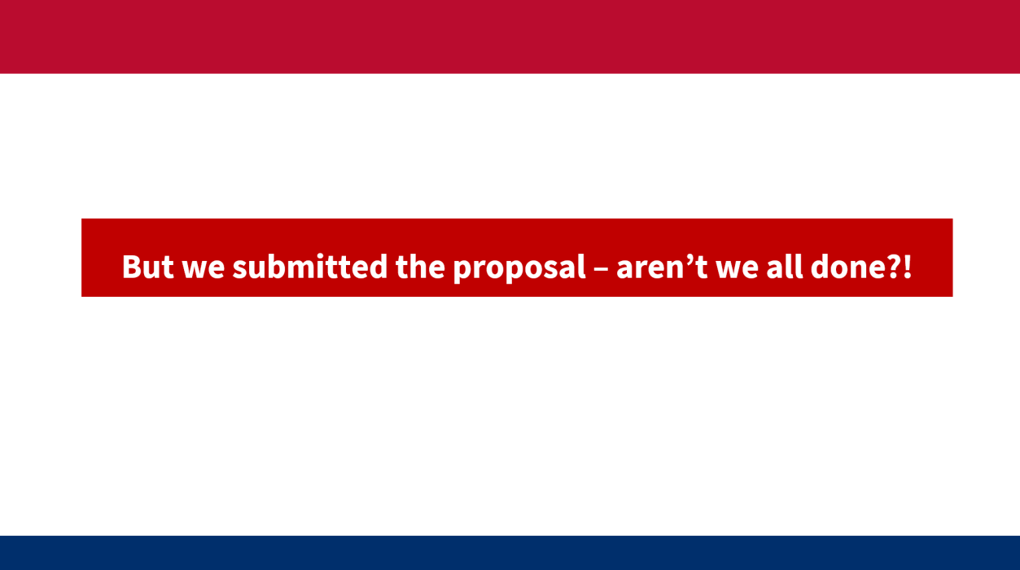

- Have them brainstorm what possibly could still remain to be done. Take a few hands from in-person participants or have virtual participants type their ideas into the chat box.
- Then project and read Slide M 6.1/#3 (below) to validate their guesses and fully answer your above question.
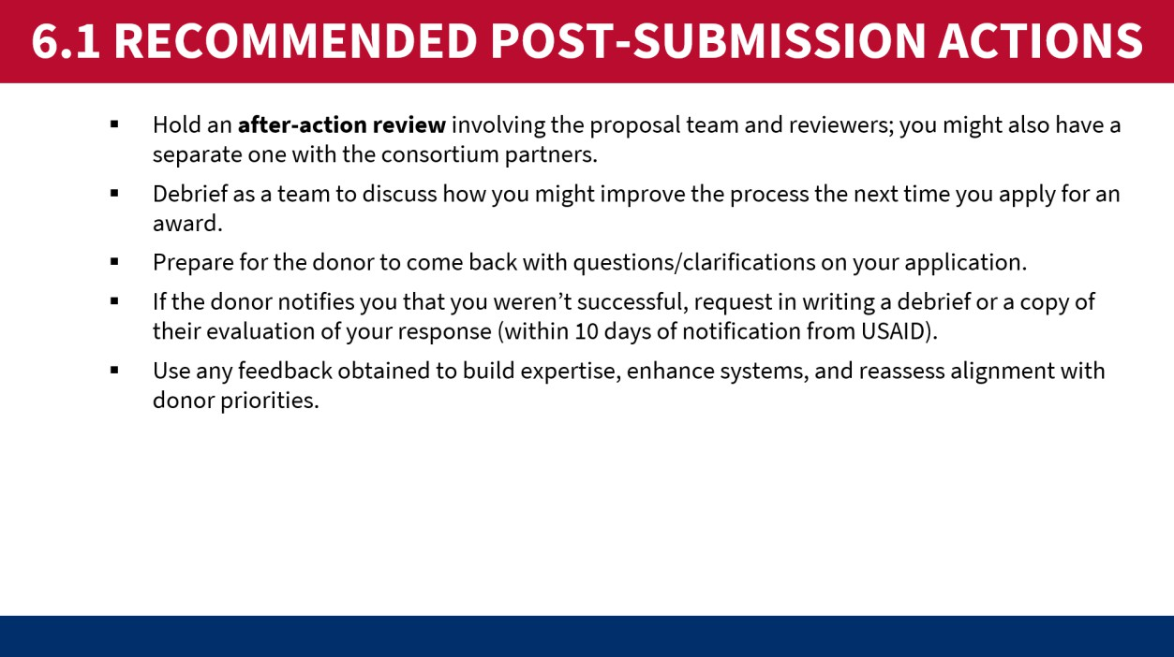
- When presenting the content of Slide M 6.1/#5, try to be motivational and inspirational – this is the last slide of the training and is meant to give the participants hope and confidence that they can do this… despite how challenging it is.
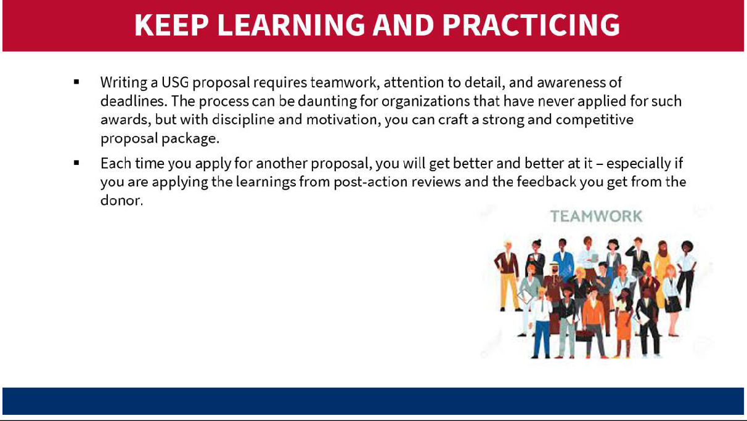

M 6.2: Wrap-up

Relevant slides: M 6.2/#6
Purpose:
  - To wrap up the training session.
  - To obtain feedback on the session, document learning outcomes and get input to improve future training.
  - To follow-up with participants after the training
Content:
  - Q&A.
  - Closing remarks and thank you messages.
  - Post-training questionnaire.
Delivery mode/activities:
- Conduct a brief energizer activity that gauges how they are feeling about the process. A few options are as follows:
  - Have them stand on an imaginary line that represents a continuum of “no confidence to high confidence” – and have a few of those on the extreme ends explain why. OR
  - Ask them to raise a colored piece of paper (having handed out one set to every participant in advance) to explain how they are currently feeling about the proposal process, whereby red means ‘not good’, yellow means ‘fine/OK’, and green means ‘great’ – and have a few from each color group explain why. OR
  - Ask them to rate their current level of confidence/readiness to undertake the proposal process on a scale of 1-5, with 1 being ‘very low’ and 5 being ‘very high’ – and have those in the extremes explain why.
- Conduct a final Question-and-Answer (Q&A) session in plenary. If time allows and if you have the available experts, an interesting way to do this could be to have a panel of BD experts – and allow time for the participants to ask them questions. The trainer/facilitator would moderate the session.
- As appropriate, representatives from the donor, organizer, and other key partners conduct speeches to emphasize key take-away messages, thank the participants (and any panelists), and make closing remarks.
- For in-person events, it can also be nice to conclude by having the participants share their main observations on what worked well and what they would’ve liked to be done differently. Have everyone stand in a circle, then toss a ball to random participants; when they hold the ball, it is like a microphone and only they are allowed to speak. They must share one positive aspect and one negative aspect about the training, then they toss it to someone else. Depending on how large the group is, this can be done just for a selection of participants – or for everyone.
- After the training, be sure to send an email to all the participants thanking them for their participation and sending the training manual and slides as well as other resources for future use.

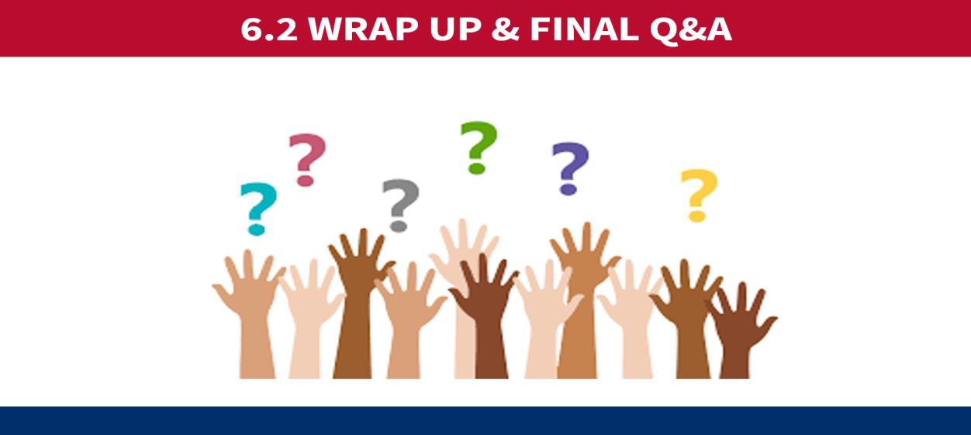

ANNEX A: PRE/POST-TRAINING QUESTIONNAIRES

Pre-Training Questionnaire
USAID/ASAP II BD TRAINING FOR USG LOCAL IMPLEMENTING PARTNERS
Pre-Training Questionnaire
Your responses to these questions will enable us to assess your needs and adjust the training to meet your expectations. Thank you in advance for your comprehensive input.
  - What are your main challenges and/or questions related to business development and proposal development for USG direct funding in particular?
  - What are the top three (3) business development topics that you would like to be covered in this training?
  - What knowledge or skills would you like to acquire from this training?
  - Does your organization have a Business Development Strategy or a Resource Mobilization Plan?
    - Yes – it’s final.
    - Yes, but in draft form or only partially finished.
    - No
  - Does your organization have a dedicated business development staff or department?
    - Yes
    - No
  - How would you characterize your experience and expertise in developing proposals for the US government and other donors? Select one:
    - None
    - Beginner
    - Proficient
    - Advanced
    - Expert
  - Please rate your current level of skill/knowledge in each topic below, on a scale of 1 to 5 (1 being very low and 5 being very high):

Topic | Self-rating (1-5)
a) The difference between Business Development and Proposal Development
b) The mechanisms and types of solicitations issued by the USG for Local Implementing Partner (LIP) funding
c) The main phases of the solicitation/proposal process
d) How to identify an opportunity
e) Key considerations for deciding whether to pursue an opportunity

Topic | Self-rating (1-5)
f) Forming a winning consortium
g) Activities to undertake before the solicitation is released (pre-positioning/capture work in preparation for the proposal process)
h) Project design and proposal development steps
i) The key components of a standard USG funding proposal
j) The different types of internal reviews of the proposal package
k) Post-submission stage activities

Post-Training Questionnaire
USAID/ASAP I & II BD TRAINING FOR USG LOCAL IMPLEMENTING PARTNERS (LIPS)
Post-Training Questionnaire
Your responses to these questions will enable us to assess learning outcomes and acquire feedback to improve this training in the future. Thank you in advance for your honest input.

1) TRAINING OBJECTIVES | Tick (✔) the box below that most closely aligns with your views: |  |  |  | Comments (Briefly explain your rating.)
 | Strongly disagree | Disagree | Agree | Strongly agree
a) As a result of this training, I increased my awareness of how the United States Government (USG) announces and solicits proposals or applications for funding opportunities, with a focus on the United States Agency for International Development (USAID) and the United States President’s Emergency Fund for AIDS Relief (PEPFAR).
b) As a result of this training, I improved my understanding of the proposal development process from pre-solicitation (capture) to post-submission (donor feedback and after-action reviews) – with a focus on solicitations from USG funding agencies such as USAID.
c) As a result of this training, I strengthened my knowledge of key considerations,
components, and criteria of successful

1) TRAINING OBJECTIVES | Tick (✔) the box below that most closely aligns with your views: |  |  |  | Comments (Briefly explain your rating.)
 | Strongly disagree | Disagree | Agree | Strongly agree
proposals for USG-funded international development programming.
d) As a result of this training, I feel better positioned to successfully pursue direct funding from the USG.
- What additional objectives would you have wanted this training to strive to achieve, if any?

…………………………………………………………………………………………………………..

…………………………………………………………………………………………………………..

…………………………………………………………………………………………………………..

- Now that you have completed the training, please rate your current level of skill/knowledge in each topic below, on a scale of 1 to 5 (1 being very low and 5 being very high):

Topic | Self-rating (1-5)
a) The difference between Business Development and Proposal Development
b) The mechanisms and types of solicitations issued by the USG for Local Implementing Partner (LIP) funding.
c) The main phases of the solicitation/proposal process.
d) How to identify an opportunity
e) Key considerations for deciding whether to pursue an opportunity
f) Forming a winning consortium
g) Activities to undertake before the solicitation is released (pre-positioning/capture work in preparation for the proposal process)
h) Project design and proposal development steps
i) The key components of a standard USG funding proposal
j) The different types of internal reviews of the proposal package

Topic | Self-rating (1-5)
k) Post-submission stage activities
- What other topics would you have wanted this training to cover, if any?

…………………………………………………………………………………………………………..

…………………………………………………………………………………………………………..

…………………………………………………………………………………………………………..

5) TRAINING DELIVERY | Tick (✔) the box below that most closely aligns with your views:
 | Strongly disagree | Disagree | Agree | Strongly agree
a) The information flowed in a logical and helpful manner.
b) The level of the training was appropriate for me; it was geared towards my level of skills, knowledge, and experience in BD.
c) There was enough balance between instruction, group work, and plenary dialogue.
d) The sessions were adequately interactive and engaging.
e) The trainer/facilitator was knowledgeable on the topic.
f) The trainer/facilitator conveyed the information clearly and effectively.
g) The training was practical (not just theoretical).
h) The duration of the training was ideal (# days and hours per day).
i) The schedule was manageable and advanced at a good pace.
j) Timekeeping was effective.
k) ICT operated well (audio, visuals, internet connection, etc.).

- Please list the two most useful topics covered by this training. How do you expect to apply the learnings?

  - ……………………………………………………………………………………………………..

  - …………………………………………………………………………………………………….

- List the two least useful topics covered by this training. Why were they not helpful?

  - ……………………………………………………………………………………………………..

  - …………………………………………………………………………………………………….

- What would you suggest should be done differently for future BD training?

…………………………………………………………………………………………………………..

…………………………………………………………………………………………………………..

…………………………………………………………………………………………………………..

- What further support, information or tools do you need to be able to prepare a successful proposal for USG direct funding? What pending questions do you still have?

…………………………………………………………………………………………………………..

…………………………………………………………………………………………………………..

…………………………………………………………………………………………………………..

- How would you describe the training overall?

…………………………………………………………………………………………………………..

…………………………………………………………………………………………………………..

…………………………………………………………………………………………………………..

ANNEX B: TOOLS AND TEMPLATES FOR THE PROPOSAL PROCESS

Capability Statement
Non-Disclosure Agreement (NDA) Pre-teaming Agreement (PTA) Teaming Agreement (TA)
RACI for Proposal Team Members Compliance Matrix

Proposal Calendar (Sample)

Proposal Review Flow Chart or Guidelines

ANNEX C: PRESENTATION SLIDE DECK

See separate PowerPoint presentation slides

ANNEX D: USEFUL LINKS TO RESOURCES
- https://usaidlearninglab.org/resources/theory-change-workbook-step-step-process-developing-or-strengthening-theories-change
- https://usaidlearninglab.org/community/blog/5-step-process-develop-or-strengthen-your-theory-change
- https://usaidlearninglab.org/community/blog/what-thing-called-theory-change
- https://usaidlearninglab.org/community/blog/theory-change-its-easier-you-think
- https://socialimpact.com/what-does-it-mean-to-have-a-strong-theory-of-change/
- https://usaidlearninglab.org/resources/draft-usaid-evidence-framework
- https://www.taproot.com/best-5-why-examples/
- https://usaidlearninglab.org/system/files/resource/files/project_logic_model_how_to_note_final_sep1.pdf
EVIDENCE SOURCES AND CLEARINGHOUSES
USAID Development Information and Analysis
- Development Experience Clearinghouse: USAID program records and development information, USAID evaluation reports, peer-reviewed journal articles, and other analyses.
- Development Data Library: USAID-funded machine-readable data
- USAID Resource Portal: portal to a selection of USAID-funded knowledge management platforms and associated research
- Country Roadmaps: visualization and trends of 17 third-party indicators curated by USAID to understand country self-reliance
- International Data and Economic Analysis Portal (IDEA): Country-level data from multiple third-party sources simultaneously
Third-party Evidence Clearinghouses
- 3ie - International Initiative for Impact Evaluation: Evidence Hub with a database of individual impact evaluations, systematic reviews, and evidence gap maps
- Cochrane Library: reviews of health evidence
- Campbell Collaboration: international social science research network that produces evidence syntheses
Other Federal Agencies' Evidence Clearinghouses
- HHS Administration of Children and Families Research and Evaluation Clearinghouses
- Dept of Education's What Works Clearinghouse
- Dept. of Labor Clearinghouse for Labor Evaluation and Research (CLEAR)

ANNEX E: DETAILED ANNUAL BUDGET
TOOL TEMPLATE: USAID Budget Template
Purpose: The purpose of this template is to calculate the budget and display it in the proposal or a work plan for USAID.
Below is an example of a modified USAID budget template
- SAMPLE OF A SUMMARY LIFE OF PROJECT (LOP) BUDGET
Budget Category | Year 1 | Year 2 | Year 3 | LOP Total
- Personnel | $ 100,000 | $ 250,000 | $ 300,000 | $ 650,000
- Fringe Benefits | $ 50,000 | $ 120,000 | $ 150,000 | $ 320,000
- Travel | $ 15,000 | $ 25,000 | $ 35,000 | $ 75,000
- Equipment | $ 200,000 | 0 | 0 | 200,000
- Supplies | $ 10,000 | $ 10,000 | $ 10,000 | $ 30,000
Total Direct Cost | $ 375,000 | $ 405,000 | $ 495,000 | $ 1,275,000
- ODCs for activities | $ 980,000 | $ 1,500,000 | $ 1,200,000 | $ 3,680,000
- Contractuals (subawards) | $ 900,000 | $ 1,280,000 | 0 | $ 2,180,000
Subtotal | $ 2,255,000 | $ 3,185,000 | $ 1,695,000 | $ 7,135,000
- Indirect Costs | $ 225,500 | $ 318,500 | $ 169,500 | $ 713,500
- Cost Share | $ 112,750 | $ 159,250 | $ 84,750 | $ 356,750
Total Award Budget | $ 2,593,250 | $ 3,662,750 | $ 1,949,250 | $ 8,205,250

- SAMPLE OF A DETAILED ANNUAL BUDGET
Cost Elements |  | Unit of Measure | Quantity | Unit Cost | Total Cost
1. Personnel
 | Salaries and Wages
 | Project Director | /Month | 12 | 9,000 | 108,000
 | Finance Officer | /Month | 12 | 4,000 | 48,000
 | Monitoring and Evaluation Director | /Month | 12 | 7,000 | 84,000
 | Grants Manager | /Month | 12 | 5,000 | 60,000
 | Consultants | /Month | 6 | 25,000 | 15,0000
 | Subtotal Personnel: |  |  |  | 315,000
2. Fringe Benefits
 | Staff Benefits and Allowances | /Month | 12 | 8,333 | 100,000
Subtotal Fringe Benefits: |  |  |  |  | 415,000
3. Travel
 | International Trips | /Trip | 0 | 0 | 0
 | Local Trips | /Trip | 8 | 5,000 | 40,000
 | Subtotal Travel: |  |  |  | 40,000
4. Equipment
 | Vehicle | /Unit | 2 | 50,000 | 100,000
 | Motorcycle | /Unit | 6 | 15,000 | 90,000
 | Subtotal Equipment: |  |  |  | 190,000
5. Contractual
 | Subaward to Organization X | /Subaward | 1 | $500,000
 | Subaward to Organization Y | /Subaward | 1 | $800,000
 | Subaward to Organization Z | /Subaward | 1 | $200,000
Subtotal Contractual: |  |  |  |  | 1,500,000
6. Supplies
 | Main office | /Month | 12 | 500 | 6,000
 | Provincial office | /Month | 12 | 100 | 1,200
 | Subtotal Supplies: |  |  |  | 7,200
7. Other Direct Costs (ODCs)
 | Activities for Objective 1 | /Year | 1 | 950,000 | 700,000
 | Activities for Objective 2 | /Year | 1 | 900,000 | 500,000
 | Activities for Objective 3 | /Year | 1 | 850,000 | 300,000
 | Subtotal ODCs: |  |  |  | 1,500,000
SUBTOTAL DIRECT COSTS |  |  |  |  | 3,967,000
INDIRECT COSTS |  | 10% (on direct costs except for equipment or contractual)* |  |  | 227,700
TOTAL ANNUAL BUDGET |  |  |  |  | 4,194,700

*The De minimis can be negotiated up to 10% of Modified Total Direct Costs

